

COMPUTER SCIENCE PRACTICAL FILE BATCH 2024-25

NAME : Sannidhya Biswas
CLASS/ SECTION : XII-B
UNIQUE ID : INDEX NUMBER :


CERTIFICATE OF AUTHENTICITY

This is to certify that Sannidhya Biswas, UID No.
___________________ is a candidate of ISC 2025 of Delhi Public School Newtown, has carried out the Computer Science practical work under the supervision of Ms. Madhurima Acharya. This practical work is truly authentic and not copied from any source.

Madhurima Acharya
(HOD Computer Science)

Sonali Sen
(Principal)

TABLE OF INDEX
S.NO | TOPICS | PG NO.
OBJECT BASED PROGRAMS
1. | Finding common elements of two arrays using objects | 6
2. | Transposition of an array using objects | 9
3. | Merging two arrays belong to different objects and finding frequency of a number in the array | 13
4. | Time class to add two times and print the final time using objects | 17
5. | Finding the difference between two matrices belong to different objects | 21
ARRAY PROGRAMS
6. | Checking if the Matrix is symmetric or not. Also calculates the sum of left and right diagonals of the matrix | 25
7. | Program to print boundary elements of a 2D array | 29
8. | Program to determine if the given matrix Magic Square Matrix | 33
9. | Program to find out saddle point Saddle Point in Matrix | 37
10. | Program to check if the matrix is a Upper Triangular Matrix | 42
11. | Program to generate Fibonacci sequence with strings | 46
12. | Program to search and deleting a word from a sentence | 49
13. | Program to decode a simple encrypted text | 51
14. | Program to remove consecutive repeated characters by replacing with its single occurrence | 54
15. | Program to calculate frequency of each alphabet present in the string | 56
DATA STRUCTURE PRGORAMS
16. | Program to implement Stack | 59
17. | Program to implement LinearQ | 61
18. | Program to implementing Dequeue | 64
19. | Program to implementing CircularQ | 68
20. | Program to implement Linked List | 71
21. | Stack using Linked List | 78
22. | Queue using Linked List | 82
INHERITANCE
23. | Calculating salary of an employee by taking data from two classes Employee and Salary | 86
24. | Program to calculate the salary of a daily wager based on number of hours worked by inheriting classes Worker and Wages | 90
25. | Program to find ranks of 50 students using inheritance of classes Records and Rank | 93
26. | Program to compute monthly telephone charge by inheriting the details from class Details into class Bill | 97
27. | Program to calculate and print perimeter and area of a parallelogram using two classes Perimeter and Area | 100
RECURSION PROGRAMS
28. | Finding out sum of the series recursively  x²/1! + x⁴/3!+x⁶/5!+….xn/(n-1)! | 102
29. | Finding out factorial of a number using recursion | 106
30. | Finding Emirp Number using recursion | 108
31. | Finding out frequency of words what begin with a vowel using recursion | 111
32. | Number of times “and” and “an” comes in a sentence using recursion | 114
MISCELLANEOUS PROGRAMS
33. | Program to perform Insertion Sort in a single dimension array | 117
34. | Program to perform Merge Sort in a single dimension array | 119
35. | Program to perform Quick Sort in a single dimension array | 122

OBJECT BASED PROGRAMS :
Question 1 :
A class Collection contains an array of 100 integers. Using the following class description, create an array with common elements from two integer arrays. Some of the members of the class are given below:

Class name : Collection Data members :
ar[] : integer array of 100 elements len : length of the array
Member methods :
Collection() : default constructor
Collection(int ) : parameterized constructor to assign the length of the array void input() : reads array elements
Collection common(Collection): return the Collection containing the common Elements of current Collection and the collection object passed as parameter. void display() : displays the array Collection elements
Write the main() method to generate the necessary output.

Algorithm:
Step 1: Start
Step 2: Declare an array arr of size 100, arr2 of size len, set J=0
Step 3: Read integers into array of len numbers
Step 4: run loop from I=0 to len
Step 5: compare the elements of two arrays at Ith position
Step 6: if they are equal, store the element in arr2[J^{th}] location
Step 7: increment I by 1
Step 8: end loop
Step 9: Print the array with common elements and loop

Step 10: Stop

Source Code:
import java.util.Scanner; public class Collection
{
int ar[]; int len;
Collection() //Constructor
{
ar = new int[0]; len = 0;
}
Collection(int l) //Parameterized Constructor
{
ar = new int[l]; len = l;
}
void input()
{
Scanner sc = new Scanner(System.in); System.out.println("Enter " + len + " integer elements:"); for (int i = 0; i < len; i++)
{
ar[i] = sc.nextInt();
}
}
Collection common1(Collection c) //Function checks for any common value and find the number of common value
{
Collection common = new Collection(len); int count = 0;
for (int i = 0; i < len; i++)
{
for (int j = 0; j < c.len; j++)
{
if (ar[i] == c.ar[j])//Finds the common value
{
common.ar[count] = ar[i]; count++;//Number of common value break;
}
}
}
common.len = count; return common;
}
void display()//Display function
{
System.out.print("Collection: ");
for (int i = 0; i < len; i++)
{
if (ar[i] != 0)
{
System.out.print(ar[i] + " ");
}
}
System.out.println();
}
public static void main(String[] args)
{
Collection c1 = new Collection(100);//1st array c1.input();//1st array value
Collection c2 = new Collection(100);//2nd array c2.input();//2nd array value
Collection common2 = c1.common1(c2);//Adjusting the number of common value in 2 array common2.display();//Displaying the common value array
}
}

VDT:

Variable | Data type | Function
ar[] | int | Stores the integer value
len | int | Stores the length of array
count | int | Stores the length of array of common elements
i | int | Stores the integer value used in loop
j | int | Stores the integer value used in loop
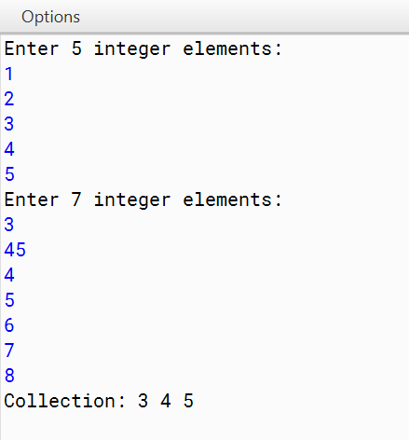
Output:
Question 2 :
A Transpose of an array is obtained by interchanging the elements of the rows and columns. A class Transarray contains a two dimensional integer array of order [m x n]. The maximum value possible for both `m’ and `n’ is
20. Design a class Transarray to find the transpose of a given matrix. The details of the members of the class are given below

Class name : Transarray
Data members/instance variables :
arr[][] : stores the matrix elements
M : integer to store the number of rows
N : integer to store the number of columns Member functions :
Transarray() : default constructor
Transarray(int mm, int nn) : to initialize the size of the matrix, m=mm, n=nn void fillarray() : to enter the elements of the matrix
void transpose(Transarray A) : to find the transpose of a given matrix void disparrary() : displays the array in a matrix form
Specify the class Transarray giving the details of the constructors, void fillarray(),void transpose(Transarray) and void disparray(). You need not write the main function.

Algorithm:
Step 1: Declare a double dimension array of size M x N
Step 2: Read elements into the array
Step 3: run outer loop from I=0 to M
Step 4: run inner loop from J=0 to N
Step 5: Temp=array [I][J]
Step 6: array[I][J] = array [J]{I]
Step 7: array [J][I] = Temp
Step 8: increment J by 1
Step 9: increment I by 1
Step 10: End inner loop
Step 11: End outer loop
Step 12: Print transposed array
Step 13: Stop

Source Code:
import java.util.Scanner; class Transarray
{
private int[][] arr; private int M; private int N; public Transarray()
{
// Default constructor M = 0;
N = 0;
arr = null;
}
public Transarray(int mm, int nn)
{
M = mm; N = nn;
if(M > 20 || N > 20)
{
System.exit(0);
}
else
{
arr = new int[M][N];
}
}
public void fillarray()
{
// Code to enter the elements of the matrix
// Assuming user input or any other desired method to fill the array Scanner scanner = new Scanner(System.in); System.out.println("Enter the elements of the matrix:");
for (int i = 0; i < M; i++)
{
for (int j = 0; j < N; j++)
{
System.out.print(" Enter the element of " + "["+j+"]"+"["+i+"] :"); arr[i][j] = scanner.nextInt();
System.out.println();
}
}
}
public void transpose()
{
// Code to find the transpose of the given matrix int[][] transposedArray = new int[N][M];
for (int i = 0; i < N; i++)

{
for (int j = 0; j < M; j++)
{
transposedArray[i][j] = arr[j][i];
}
}
arr = transposedArray; int temp = M;
M = N;
N = temp;
}
public void disparray()
{
// Code to display the array in matrix form System.out.println("Matrix:");
for (int i = 0; i < M; i++)
{
for (int j = 0; j < N; j++)
{
System.out.print(arr[i][j] + " ");
}
System.out.println();
}
}
}

VDT:

Variable | Datatype | Function
arr[][] | int | Stores the integer value
transposedArray[][] | int | Stores the integer value
M | int | Stores the number of rows
N | int | Stores the number of columns
i | int | Stores the integer value used in loop
j | int | Stores the integer value used in loop
mm | int | Stores the number of rows
nn | int | Stores the number of columns
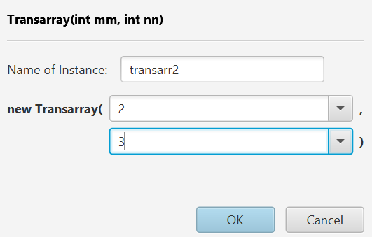
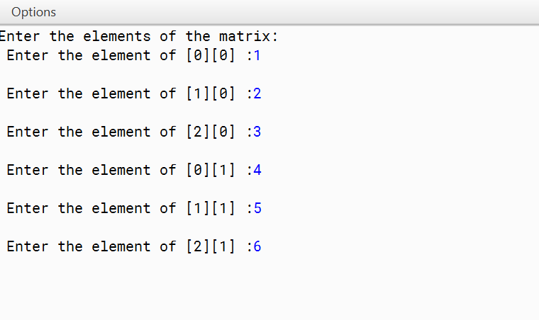
Output:

Before Transposing the Matrix | After Transposing the Matrix
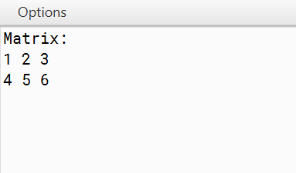 | 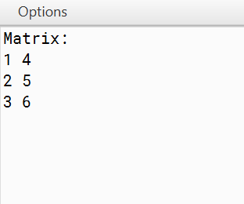

Question 3:
A class Array is declared as follows:
Class name : Array Data members :
ar[] : integer array of size 100 n : size of the array
num : integer variable Member methods :
Array() : a constructor to store 0 at each location of ar[] and to n. void getArray() : to input n integers in array
int process(Array B, int k): to assign k to num and return the frequency of num from the array ar[] from the array object B.
Array merge(Array a) : merge the current array with the parameterized array.
void display() : to print the array elements in such a way that only 4 elements of the array should be printed in one line with two spaces in between the numbers.
Write main() method and call the above methods to generate the output.

Algorithm:
Step 1: Declare two integer arrays of size N
Step 2: Read elements into the arrays
Step 3: Enter the number whose frequency to be checked in K
Step 4: Run loop from I=0 to N
Step 5: Check if array1[I]=K then increment CTR by 1
Step 6: End loop
Step 7: Declare a third array of size array1.N + array2.N, set X=0
Step 8: Run loop from I=0 to array1.N
Step 9: Shift the elements of array1 to array 3 by array3[X++]=array1[I]
Step 10: Increment I by 1
Step 11: End loop
Step 12: Run a loop from I=0 to array2.N
Step 13: Shift the elements of array2 to array 3 by array3[X++]=array2[I]
Step 14: Increment I by 1
Step 15: End loop
Step 16: Print the merged array
Step 17: Stop

Source Code:
import java.util.Scanner; class Array
{
private int[] ar; private int n; private int num;
public Array() //a constructor to store 0 at each location of ar[] and to n
{
ar = new int[100];
for (int i = 0; i < 100; i++)
{
ar[i] = 0;
}
n = 0;
}
public void getArray()//to input n integers in array
{
Scanner scanner = new Scanner(System.in); System.out.print("Enter the size of the array: "); n = scanner.nextInt();
System.out.println("Enter " + n + " integers:"); for (int i = 0; i < n; i++)
{
ar[i] = scanner.nextInt();
}
}
public int process(Array B, int k) //to assign k to num and return the frequency of num from the array ar[] from the array object B.
{
num = k;
int frequency = 0;
for (int i = 0; i < n; i++)
{
if (ar[i] == num)
{
frequency++;//Frequency of the number
}
}
return frequency;
}
public Array merge(Array a)//merge the current array with the parameterized array
{
Array mergedArray = new Array(); mergedArray.n = n + a.n;
for (int i = 0; i < n; i++) // Merging loop
{
mergedArray.ar[i] = ar[i];
}
for (int i = 0; i < a.n; i++)
{
mergedArray.ar[n + i] = a.ar[i];
}
return mergedArray;
}
public void display() //to print the array elements in such a way that only 4 elements of array should be printed in one line with two spaces in
between the numbers.
{
System.out.println("Array Elements:"); for (int i = 0; i < n; i++) //Display loop
{
System.out.print(ar[i] + " "); if ((i + 1) % 4 == 0)
{
System.out.println();
}
}
System.out.println();
}
public static void main(String[] args) //main method
{
Array array1 = new Array(); Array array2 = new Array(); array1.getArray();
System.out.print("Enter a number to process: "); Scanner scanner = new Scanner(System.in);
int number = scanner.nextInt();
int frequency = array1.process(array2, number); System.out.println("Frequency of " + number + ": " + frequency); array2.getArray();
Array mergedArray = array1.merge(array2); array1.display();
array2.display(); mergedArray.display();
}
}

VDT:

Variable | Datatype | Function
ar[] | int | Stores the integer value
n | int | Stores the length of array
num | int | Stores the number to be searched
i | int | Stores the integer value used in loop
number | int | Stores the number to be searched
k | int | Stores the number to be searched
frequency | int | Stores the frequency of the number
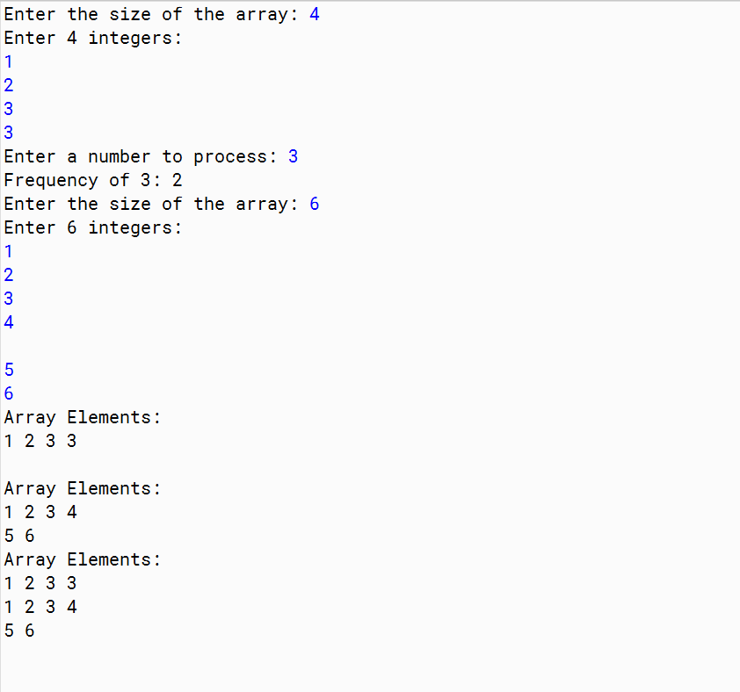
Output:

Question 4
A class Time is declared as follows:
Class name : Time Data members :
hrs, min : integers to store hour and minute Methods :
Time() : default constructor to assign 0 to data members void getTime(int h, int m): assigns hours and minutes void printTime() : prints time in hh:mm format
Time sumTime(Time t1, Time t2): adds two time t1 with t2 and return their sum.
Implement the above class and write main() method and call the above methods to generate the output.

Algorithm:
Start 1: Start
Step 2: Read hours and mins of Time1
Step 3: Read hours and mins of Time2
Step 4: Create a temporary object Time3
Step 5: Perform Time3->hours= Time1->hours+Time->hours
Step 6: Perform Time3->min= Time1>min+Time2>min
Step 7: If Time3.mins >=60 then
Step 8: Time3->hours+=Time3->min/60
Step 9: Time3->mins=Time3->min%60
Step 10: Display Time3
Step 11: Stop

Source Code:
class Time
{
private int hrs; private int min; public Time()
{
hrs = 0;
min = 0;
}
public void getTime(int h, int m)
{
hrs = h; min = m;
}
public void printTime()
{
System.out.printf("%02d:%02d\n", hrs, min);//Printing in time format
}
public static Time sumTime(Time t1, Time t2)
{
Time sum = new Time(); sum.hrs = t1.hrs + t2.hrs; sum.min = t1.min + t2.min; if (sum.min >= 60)
{
sum.hrs += sum.min / 60; sum.min %= 60;
}
return sum;
}
public static void main(String[] args)
{
Scanner sc = new Scanner(System.in);
// Taking Input for Time 1 and Time 2 System.out.println("Time 1 hour:"); int h1 = sc.nextInt(); System.out.println("Time 1 minutes:"); int m1 = sc.nextInt(); System.out.println("Time 2 hour:"); int h2 = sc.nextInt(); System.out.println("Time 2 minutes:"); int m2 = sc.nextInt();
// Create two Time objects Time time1 = new Time(); Time time2 = new Time();
// Set the time values time1.getTime(h1, m1);

time2.getTime(h2, m2);
// Print the individual times System.out.println("Time 1:"); time1.printTime(); System.out.println("Time 2:"); time2.printTime();
// Sum the two times and print the result
Time sumTime = Time.sumTime(time1, time2); System.out.println("Sum of Time 1 and Time 2:"); sumTime.printTime();
}
}

VDT:

Variable | Datatype | Function
hrs | int | Stores the hour value
min | int | Stores the minute value
h1 | int | Stores the hour value
h2 | int | Stores the minute value
m1 | int | Stores the hour value
m2 | int | Stores the minute value
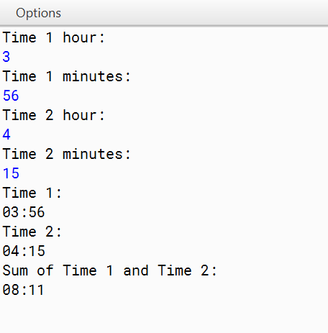
Output:

Question 5 :
Class Matrix contains a two dimensional integer array of order [ m x n ]. The maximum value possible for both m and n is 25. Design a class Matrix to find the difference of the two matrices. The details of the members of the class are given below:
Class name : Matrix Data members
arr[][] : stores the matrix element
m : integer to store the number of rows
n : integer to store the number of columns Member functions:
Matrix(int mm, int nn) : to initialize the size of the matrix m=mm and n=nn void fillarray() : to enter the elements of the matrix
Matrix SubMat(Matrix A) : subtract the current object from the matrix of the parameterized object and return the resulting object.
void display() : display the matrix elements.
Specify the class Matrix giving details of the constructor(int,int), void fillarray(),Matrix SubMat(Matrix) and void display(). Define the main() function to create an object and call the functions accordingly to enable the task.

Algorithm:
Step 1: Start
Step 2: Read the value of row and column and declare matrix A[r][c], B[r][c], C[r][c]
Step 3: Read the values in A[][] and B[][]
Step 4: Declare variable i=0, j=0
Step 5: Repeat until i < r
Step 6: Repeat until j < c
Step7: Perform C[i][j]=A[i][j] - B[i][j]
Step 8: Set j=j+1
Step 9: End inner loop
Step 10: Set i=i+1
Step 11: End outer loop
Step 12: display matrix C[][]
Step 13: Stop

Source Code:
import java.util.Scanner; class Matrix
{
private int[][] arr;//stores the matrix element private int m;//integer to store the number of rows
private int n;//integer to store the number of coloumns
public Matrix(int mm, int nn)//to initialize the size of the matrix m=mm and n=nn
{
m = mm; n = nn;
arr = new int[m][n];
}
public void fillArray() //to enter the elements of the matrix
{
Scanner scanner = new Scanner(System.in); for (int i = 0; i < m; i++)
{
for (int j = 0; j < n; j++)
{
arr[i][j] = scanner.nextInt();
}
}
}
public Matrix subMat(Matrix A)//subtract the current object from the matrix of the parameterized object and return the resulting object.
{
Matrix result = new Matrix(m, n); for (int i = 0; i < m; i++)
{
for (int j = 0; j < n; j++)
{
result.arr[i][j] = arr[i][j] - A.arr[i][j];
}
}
return result;
}
public void display()//display the matrix elements
{
System.out.println("Matrix elements:"); for (int i = 0; i < m; i++)
{
for (int j = 0; j < n; j++)
{
System.out.print(arr[i][j] + " ");
}
System.out.println(); }
}
public static void main(String[] args)
{
Scanner scanner = new Scanner(System.in); System.out.println("Enter the number of rows (m):"); int m = scanner.nextInt();
System.out.println("Enter the number of columns (n):"); int n = scanner.nextInt();
Matrix matrix1 = new Matrix(m, n); Matrix matrix2 = new Matrix(m, n);
System.out.println("Enter elements for matrix 1:"); matrix1.fillArray();
System.out.println("Enter elements for matrix 2:"); matrix2.fillArray();
Matrix diffMatrix = matrix1.subMat(matrix2); System.out.println("Matrix 1:"); matrix1.display();
System.out.println("Matrix 2:"); matrix2.display();
System.out.println("Difference of Matrix 1 and Matrix 2:"); diffMatrix.display();
}
}

VDT:

Variable | Datatype | Function
arr[] | int | Stores the integer value
m | int | Stores the no of rows
n | int | Stores the no of columns
mm | int | Stores the no of rows
nn | int | Stores the no of columns
i | int | Stores the integer value used in loop
j | int | Stores the integer value used in loop

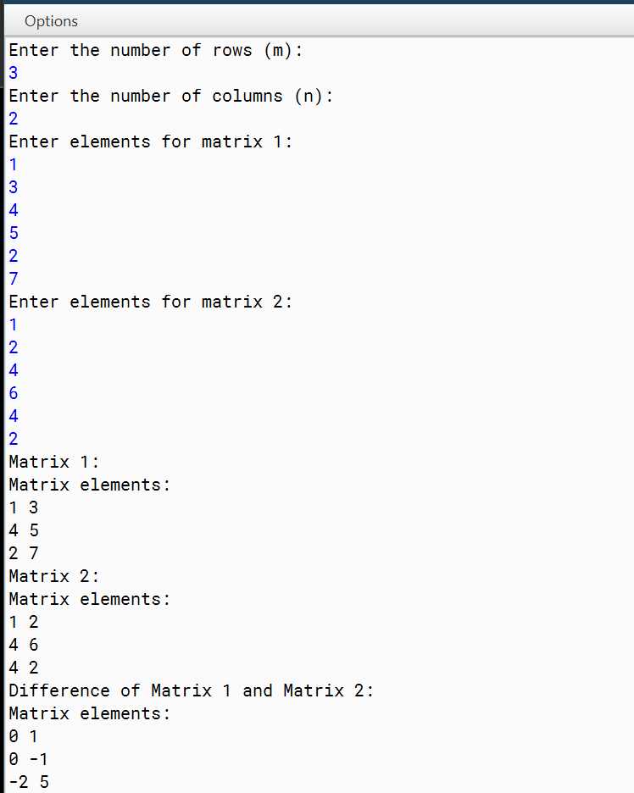
Output:

ARRAY PROGRAMS :
Question 6:
Write a program to declare a square matrix A[ ] [ ] of order (M x M) where ‘M’ is the number of rows and the number of columns such that M must be greater than 2 and less than 10. Accept the value of M as user input. Display an appropriate message for an invalid input. Allow the user to input integers into this matrix. Perform the following
tasks:
- Display the original matrix.
- Check if the given matrix is Symmetric or not.
A square matrix is said to be Symmetric, if the element of the i th row and j th column is equal to the element of the j th row and i th column.
- Find the sum of the elements of the left diagonal and the sum of the elements of the right diagonal of the matrix and display them.

Algorithm:
Step 1: Start
Step 2: Declare a matrix A[m][m]
Step 3: Read values in matrix A
Step 4: Run loop from I=0 to m
Step 5: Run loop from J=0 to m
Step 6: check if A[I][J] ≠ A[J][I] then
Step 7: Print array is not symmetric
Step 8: Terminate loop
Step 9: End loop
Step 10: End loop
Step 11: Print Array is symmetric
Step 12: Run loop from I=0 to m
Step 13: Set SUM1+= A[I][I]
Step 14: Set SUM2+=A[J][I]
Step 15: End loop
Step 16: Print SUM1 and SUM2

Step 17: Stop

Source Code:
Import java.util.Scanner; class Matrix
{
int[][] arr; int size;
Matrix(int size)
{
this.size = size;
arr = new int[size][size];
}
public void fillMatrix()//Inputting the elements of matrix
{
Scanner scanner = new Scanner(System.in); System.out.println("Enter the elements of the matrix:"); for (int i = 0; i < size; i++)
{
for (int j = 0; j < size; j++)
{
arr[i][j] = scanner.nextInt();
}
}
}
public void displayMatrix()//Displaying the matrix
{
System.out.println("Original Matrix:"); for (int i = 0; i < size; i++)
{
for (int j = 0; j < size; j++)
{
System.out.print(arr[i][j] + " ");
}
System.out.println();
}
}
public boolean isSymmetric()//Checking if the matrix is symmetric
{
for (int i = 0; i < size; i++)
{
for (int j = 0; j < size; j++)
{
if (arr[i][j] != arr[j][i])
{
return false;
}
}
}
return true;
}
public int sumLeftDiagonal()//Calculates the elements in left diagonal
{
int sum = 0;
for (int i = 0; i < size; i++)
{
sum += arr[i][i];
}
return sum;
}
public int sumRightDiagonal()//Calculates the elements in right diagonal
{
int sum = 0;
for (int i = 0; i < size; i++)
{
sum += arr[i][size - 1 - i];
}
return sum;
}
public static void main(String[] args)
{
Scanner scanner = new Scanner(System.in); System.out.println("Enter the size of the square matrix (M):"); int M = scanner.nextInt();
if (M <= 2 || M >= 10)
{
System.out.println("Invalid input! M must be greater than 2 and less than 10."); return;
}
Matrix matrix = new Matrix(M); matrix.fillMatrix(); matrix.displayMatrix();
if (matrix.isSymmetric())
{
System.out.println("The matrix is symmetric.");
}
else
{
System.out.println("The matrix is not symmetric.");
}
int sumLeftDiagonal = matrix.sumLeftDiagonal(); int sumRightDiagonal = matrix.sumRightDiagonal();
System.out.println("Sum of the elements of the left diagonal: " + sumLeftDiagonal); System.out.println("Sum of the elements of the right diagonal: " + sumRightDiagonal);
}
}

VDT:

Variable | Datatype | Function
arr[][] | int | Stores the integer value
size | int | Stores the size of array
sum | int | Stores the sum of diagonals
M | int | Stores the size of array
sumLeftDiagonal | int | Stores the sum of left diagonal
sumLeftDiagonal | int | Stores the sum of right diagonal
i | int | Stores the integer value used in loop
j | int | Stores the integer value used in loop
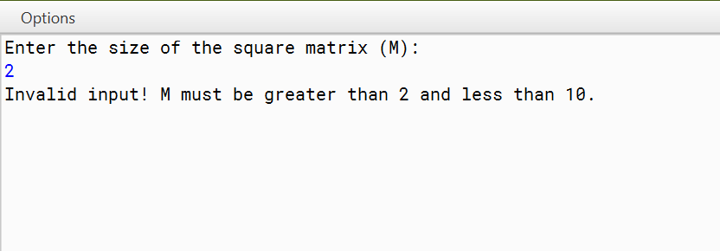
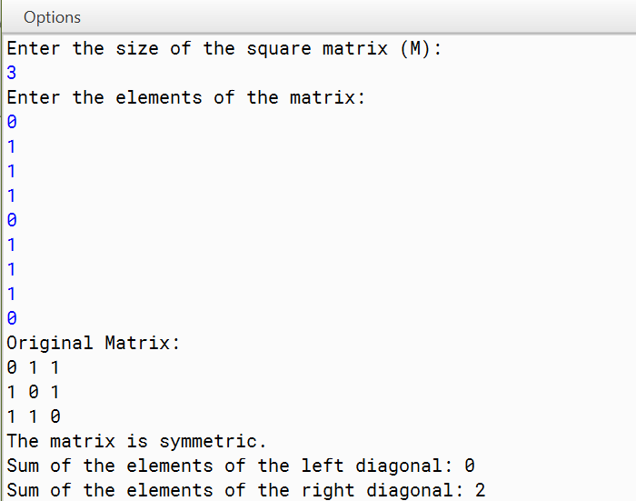
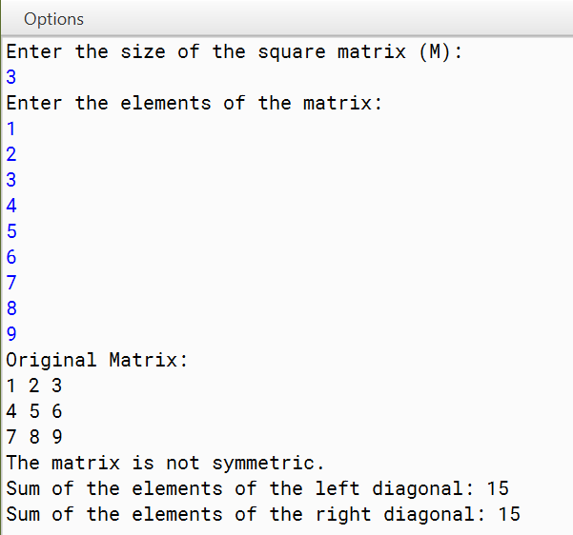
Output:

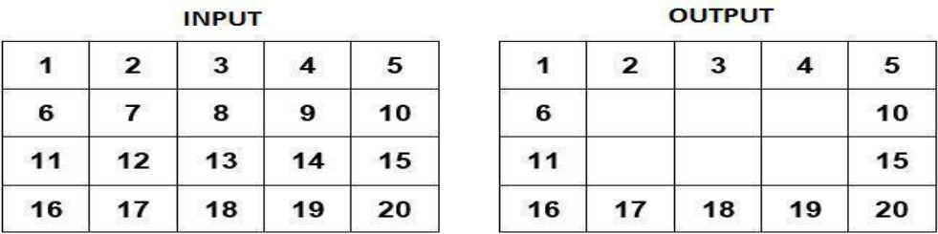
Question 7 :
Write a Program in Java to input a 2-D array of size ‘m*n’ and print its boundary (border) elements.

Algorithm:
Step 1: Start
Step 2: Read rows and column in m and n
Step 3: Read values in array
Step 4: Run loop from I=0 to m
Step 5: Run loop from J=0 to m
Step 6: check if (I=0) or (I=(m-1)) or (J=0) or (J=(n-1))
Step 7: Print A[I][J]
Step 8: End loop
Step 9: Stop

Source Code:
import java.util.Scanner; class BorderMatrix
{
String[][] arr; int M;
int N;
BorderMatrix(int m, int n)//Parameterised constructor
{
M = m; N = n;
arr = new String[M][N];
}
public void fillMatrix()//Inputting elements
{
Scanner scanner = new Scanner(System.in); System.out.println("Enter the elements of the matrix:"); for (int i = 0; i < M; i++)
{
for (int j = 0; j < N; j++)
{
arr[i][j] = scanner.next()+"\t";//Tabular format
}
}
}
public void displayMatrix()//Displaying matrix
{
for (int i = 0; i < M; i++)
{
for (int j = 0; j < N; j++)
{
System.out.print(arr[i][j] + " ");
}
System.out.println();
}
}
void borderMatrix()//Function to represent only border elements
{
for (int i = 1; i < M-1 ; i++)
{
for (int j = 1; j < N-1; j++)
{
arr[i][j] = "\t";//Tabular format
}
}
}
public static void main(String[] args)
{
Scanner scanner = new Scanner(System.in); System.out.println("Enter the number of rows:"); int M = scanner.nextInt();
System.out.println("Enter the number of coloumns:"); int N = scanner.nextInt();
BorderMatrix obj = new BorderMatrix(M,N); obj.fillMatrix();
System.out.println("Original Matrix"); obj.displayMatrix(); obj.borderMatrix();
System.out.println("Matrix with border elements only"); obj.displayMatrix();
}
}

VDT:

Variable | Datatype | Function
arr[][] | int | Stores the integer value
M | int | Stores the no of columns
N | int | Stores the no of rows
m | int | Stores the no of columns
n | int | Stores the no of rows
i | int | Stores the integer value used in loop
j | int | Stores the integer value used in loop
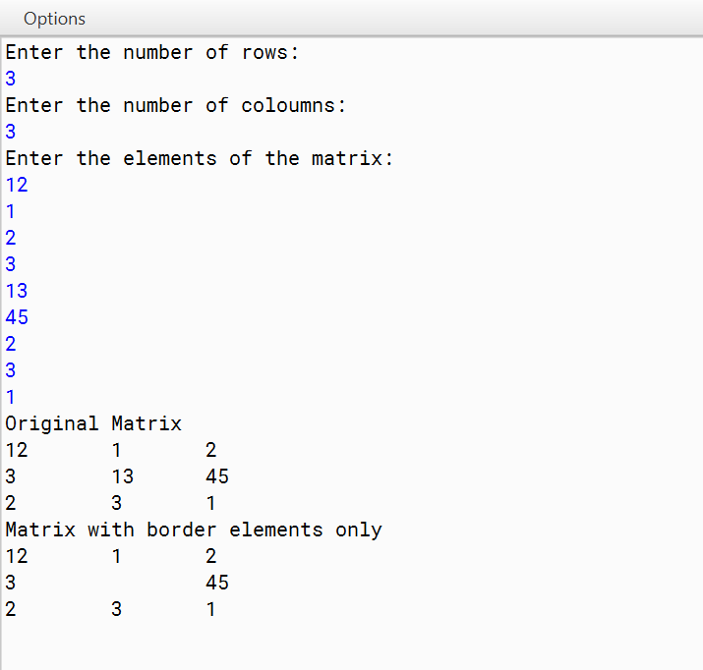
Output:

Question 8 :
Write a program to check if the given matrix is a Magic Square Matrix or not. A square matrix is said to be a Magic Square, if the sum of each row, each column and each diagonal is the same. Write a program to enter an integer number ‘n’. Create a magic square of size ‘n*n’. Finally, print the elements of the matrix as Magic Square.

Algorithm:
Step 1: Start
Step 2: Read a matrix A[][] of mxm size
Step 3: Set RSUM=0, CSUM=0, D=0
Step 4: Run loop from I =0 to M
Step 5: D=D+A[I][I]
Step 6; End loop
Step 7: Run loop from I =0 to M
Step 8: Set RSUM=0, CSUM=0
Step 9: Run loop from J=0 to M
Step 10: RSUM=RSUM+A[I][J]
Step 11: CSUM=CSUM+A[J][I]
Step 12: end loop
Step 13: If CSUM ≠D or RSUM ≠ D then Set FLAG= FALSE
Step 14: Print Not Magic Square
Step 15: terminate loop
Step 16: End loop
Step 17: If FLAG=TRUE then
Step 18: Print Magic Square
Step 19: Stop

Source Code:
import java.util.Scanner; class MagicMatrix
{
int[][] arr; int size;
MagicMatrix(int s)//Parameterised constructor
{
size = s;
arr = new int[size][size];
}
public void fillMatrix()//Accepting values of array
{
Scanner scanner = new Scanner(System.in); System.out.println("Enter the elements of the matrix:"); for (int i = 0; i < size; i++)
{
for (int j = 0; j < size; j++)
{
arr[i][j] = scanner.nextInt();
}
}
}
public void displayMatrix()//Displaying the array
{
for (int i = 0; i < size; i++)
{
for (int j = 0; j < size; j++)
{
System.out.print(arr[i][j] + " ");
}
System.out.println();
}
}
boolean magicMatrix()//Checks whether the given array is magic Matrix
{
int S1[] = new int[size]; boolean b = true;
for (int i = 0; i < size ; i++)
{
for (int j = 0; j < size; j++)
{
S1[i]+=arr[i][j];
}
}
int S2[] = new int[size]; for (int i = 0; i < size ; i++)
{
for (int j = 0; j < size; j++)
{
S2[i]+=arr[j][i];
}
}
int S3 = 0;
for (int j = 0; j < size; j++)
{
S3+=arr[j][j];
}
int S4 = 0;
for (int i = size-1,j = 0; i >= 0 ; i--, j++)
{
S4+=arr[i][j];
}
for (int i = 1; i < size ; i++)
{
if(S1[i] != S3 || S1[i] != S4 || S2[i] != S3 || S2[i] != S4 )
{
b = false;
}
}
return b;
}
public static void main(String[] args)//Main method
{
Scanner scanner = new Scanner(System.in); System.out.println("Enter the size:");
int Size = scanner.nextInt();
MagicMatrix obj = new MagicMatrix(Size); obj.fillMatrix();
System.out.println("Your number square:"); obj.displayMatrix();
if(obj.magicMatrix() == true)
{
System.out.println("Magic square");
}
else
{
System.out.println("Not a Magic square");
}
}
}

VDT:

Variable | Datatype | Function
arr[] | int | Stores the integer value
size | int | Stores the size of array
s | int | Stores the size of array
S1 | int | Stores the sum of rows
S2 | int | Stores the sum of column
S3 | int | Stores the sum of primary diagonal
S4 | int | Stores the sum of secondary diagonal
b | boolean | Stores true/false
i | int | Stores the integer value used in loop
j | int | Stores the integer value used in loop

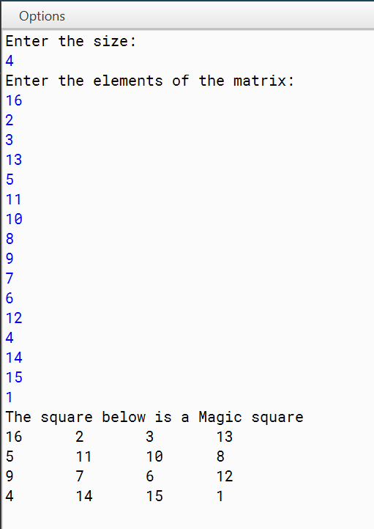
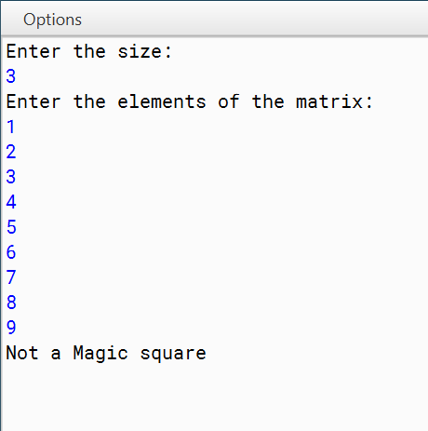
Output:

Question 9 :
Write a program to declare a square matrix A[ ][ ] of order ‘n’. Allow the user to input positive integers into this matrix. Perform the following tasks on the matrix:
- Output the original matrix.
- Find the SADDLE POINT for the matrix. If the matrix has no saddle point, output the message “NO SADDLE POINT”.
[Note: A saddle point is an element of the matrix such that it is the minimum element for the row to which it belongs and the maximum element for the column to which it belongs. Saddle point for a given matrix is always unique.]

Algorithm:
Step 1: Start
Step 2: Read elements in matrix MAT[][] of mxm size
Step 3: Run loop from I=0 to M
Step 4: Set MINROW=MAT[I][0] and COLIND = 0
Step 5: Run loop J=1 to M
Step 6: If MINROW> MAT[I][J] then
Step 7: MINROW=MAT[I][J] and COLIND=J
Step 8: End loop
Step 9: Run loop K=0 to M
Step 10: If MINROW< MAT[K][COLIND] then end loop
Step 11: If K=M then
Step 12: Print Saddle point is MINROW
Step 13: end loop
Step 13: Stop

Source Code:
import java.util.Scanner; class SaddlePoint
{
public static void main(String args[])
{
Scanner in = new Scanner(System.in); System.out.print("Enter the size of the matrix: "); int n = in.nextInt();
int a[][] = new int[n][n];
System.out.println("Enter elements of the matrix: "); for (int i = 0; i < n; i++) //Taking Input
{
System.out.println("Enter Row "+ (i+1) + " :"); for (int j = 0; j < n; j++)
{
a[i][j] = in.nextInt();
if (a[i][j] < 0)
{
System.out.print("Invalid Input"); return;
}
}
}
System.out.println("Matrix A[ ][ ]"); printMatrix(a, n, n);
//Find the Saddle Point boolean found = false;
for (int i = 0; i < n; i++) //loop changes to every row
{
int Min = a[i][0]; int check = 0;
for (int j = 1; j < n; j++) //loop changes columns and checks Min value
{
if (Min > a[i][j])
{
Min = a[i][j]; check = j;
}
}

point
int k = 0;
for (k = 0; k < n; k++) //If the Min value is lower than its corresponding column then it is not Saddle

{

if (Min < a[k][check])
{

break;
}
}
if (k == n) //Only a saddle point would have greatest value in column while having min value in its row
{
found = true;
System.out.println("Saddle Point = " + Min); break;
}
}
if (!found)
{
System.out.println("No Saddle Point");
}
}
public static void printMatrix(int arr[][], int n)//Printing
{
for (int i = 0; i < n; i++)
{
for (int j = 0; j < n; j++)
{
System.out.print(arr[i][j] + "\t");
}
System.out.println();
}
}
}

VDT:

Variable | Datatype | Function
a[][] | int | Stores the integer value
arr[][] | int | Stores the integer value
n | int | Stores the length of array
Min | int | Stores the minimum value of the element in column
check | int | Stores the column where minimum value was found
i | int | Stores the integer value used in loop
j | int | Stores the integer value used in loop

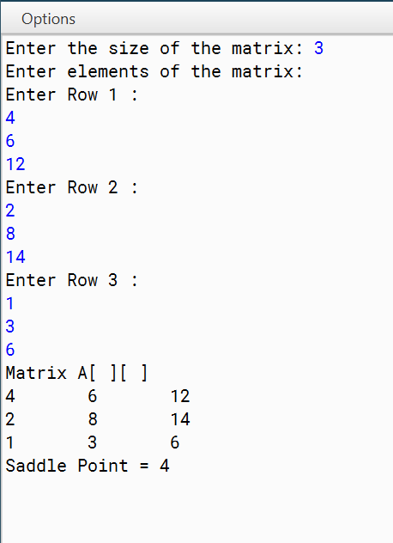
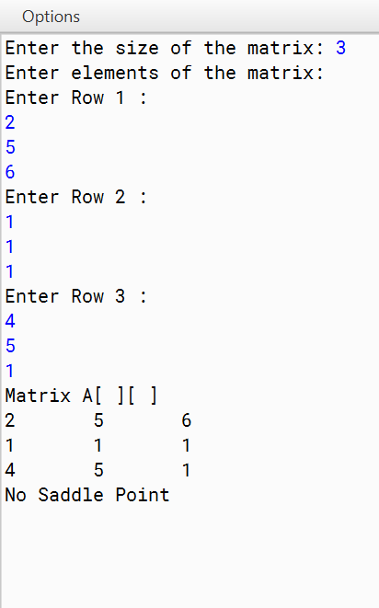
Output:

Question 10
Write a Program in Java to input a 2-D square matrix and check whether it is an Upper Triangular Matrix or not.
Upper Triangular Matrix : An Upper Triangular matrix is a square matrix in which all the entries below the main diagonal () are zero. The entries above or on the main diagonal themselves may or may not be zero.

Algorithm:
STEP 1: START
STEP 2: DEFINE rows, cols
STEP 3: INITIALIZE matrix a[][] ={{1,2,3},{8, 6, 4}, {4, 5, 6}}
STEP 4: rows = a.length
STEP 5: cols = a[0].length
STEP 6: if(rows!=cols)
then PRINT "Matrix should be a square matrix" else Go to step 7
STEP 7: REPEAT STEP 8 to STEP 10 UNTIL i<rows
STEP 8: REPEAT STEP 9 UNTIL j<cols
STEP 9: If(i>j) then PRINT 0 else PRINT a[i][j]
STEP 10: PRINT new line
STEP 11: END

Source Code:
import java.util.Scanner; class UpperTriangle
{ int N;
int Matrix[][];
UpperTriangle(int nn)//Parameterised Constructor
{
N = nn;
Matrix = new int[nn][nn];
}
void fillMatrix()//Input the elements
{
Scanner sc = new Scanner(System.in); System.out.println("Enter the elements"); for(int i = 0; i < N; i++)
{
for(int j = 0; j < N; j++)
{
Matrix[j][i] = sc.nextInt();
}
}
}
Boolean isUpperTriangularMatrix()//Check for UpperTriangle
{
for (int i = 1; i < N ; i++)
{
for (int j = 0; j < i; j++)
{
if (Matrix[j][i] != 0)
{
return false;
}
}
}
return true;
}
void displayMatrix()//Printing the matrix
{
for(int i = 0; i < N; i++)
{
for(int j = 0; j < N; j++)
{
System.out.print(Matrix[j][i]+"\t");
}
System.out.println();
}
}
public static void main(String argc[])//Main Method
{
Scanner sc = new Scanner(System.in); System.out.println("Enter size");
int n = sc.nextInt();
UpperTriangle obj = new UpperTriangle(n); obj.fillMatrix();
if (obj.isUpperTriangularMatrix() == true)
{
System.out.println("Upper Triangle Matrix"); obj.displayMatrix();
}
else
{
System.out.println("Not an Upper Triangle Matrix"); obj.displayMatrix();
}
}
}

VDT:

Variable | Datatype | Function
Matrix[][] | int | Stores the integer value
N | int | Stores the size of array
nn | int | Stores the size of array
n | int | Stores the size of array
i | int | Stores the integer value used in loop
j | int | Stores the integer value used in loop

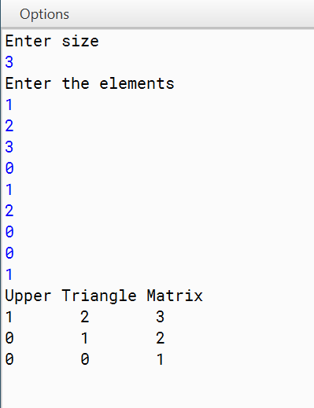
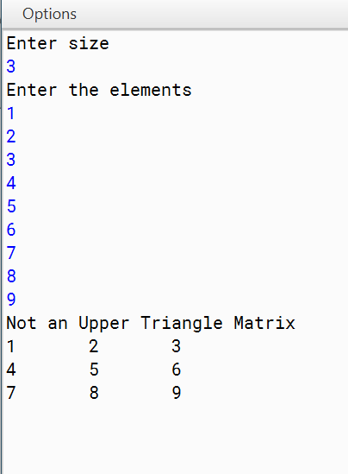
Output:

Question 11:
A sequence of Fibonacci Strings is generated as follows:
S₀ = “a”, S₁ = “b”, S_{n} = S_{(n-1)} + S_{(n-2)} where ‘+’ denotes concatenation. Thus the sequence is:
a, b, ba, bab, babba, babbabab, n terms.

Design a class FiboString to generate Fibonacci strings. Some of the members of the class are given below:
Class name : FiboString Data members/instance variables:
- : to store the first string
- : to store the second string
- : to store the concatenation of the previous two strings
n : to store the number of terms Member functions/methods:
FiboString() : constructor to assign x=”a”, y=”b”, z=”ba” void accept() : to accept the number of terms ‘n’
void generate() : to generate and print the fibonacci strings. The sum of (‘+’ i.e. concatenation) first two strings is the third string. Eg. “a” is the first string, “b” is the second string then the third string will be “ba” and fourth will be “bab” and so on.

Algorithm:
Step 1: Start
Step 2: Let x = “a”, y = “b”, z = “ba”
Step 3: Read value of the number of terms and store it in n
Step 4: If n == 1, display “a”
Step 5: If n == 2, display “a,b”
Step 6: If n > 2, display “a,b,ab”
Step 7: Run a loop from I = 0 to I <= n-3 (where i is the Loop Control Variable)
Step 8: x = z
Step 9: z = z + y
Step 10: Display z + “,”
Step 11: y = x
End Loop
Step 12: End

Source Code:
import java.util.Scanner; class FiboString
{
String x, y, z; int n;
FiboString ()//Default Constructor
{
x = "a";
y = "b";
z = "ba";
}
void accept ()//Input the value of number of terms
{
Scanner sc = new Scanner( System.in ); System.out.print( "Enter number of terms: "); n = sc.nextInt();
}
void generate ()//Generate the string
{
if( n == 1 )
{
System.out.print ( x );//Default
}
else if( n==2 )
{
System.out.print ( x + " " + y );//Default
}
else
{
System.out.print ( x + " " + y + " ");
for( int i = 1; i <= (n-2) ; i++ )//Pattern loop for the program
{
z = y + x;
System.out.print ( z + " "); x=y;
y=z;
}
}
System.out.println ();
}
public static void main ( String args[] )//Main method
{
FiboString fs = new FiboString (); fs.accept();
fs.generate();
}
}

VDT:

Variable | Datatype | Function
x | String | Stores the String value
y | String | Stores the String value
z | String | Stores the String value
i | int | Stores the integer value used in loop

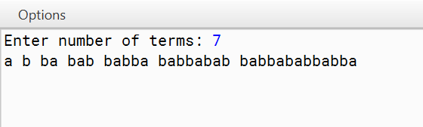
Output.

Question 12 :
Write a program to accept a sentence which may be terminated by either ‘.’ ‘?’ or ‘!’ only. Any other character may be ignored. The words may be separated by more than one blank space and are in UPPER CASE. Perform the following tasks:
- Accept the sentence and reduce all the extra blank space between two words to a single blank space.
- Accept a word from the user which is part of the sentence along with its position number and delete the word and display the sentence.

Algorithm:
STEP 1: START
STEP 2: INITIALIZE str, wordCount, array strArr[] STEP 3: Accept the value of str from the user
STEP 4: Set the value of wordCount to the number of words in st
STEP 5: Using a loop and wordCount limiter, set the elements of array strArr to the word in the string one by one
STEP 6: If the sentence does not have “.”, “!” and “?” then Print “Invalid Input” STEP 7: To remove spaces run another loop and concatenate the elements of the array STEP 8: Also remove extra front and back spaces
STEP 9: Print the new String STEP 10: STOP

Source Code:
import java.util.*; class StringCheck
{
public static String sortString(String ipStr)
{
StringTokenizer st = new StringTokenizer(ipStr); int wordCount = st.countTokens();
String strArr[] = new String[wordCount]; for (int i = 0; i < wordCount; i++)
{
strArr[i] = st.nextToken();
}
StringBuffer sb = new StringBuffer(); for (int i = 0; i < wordCount; i++)
{
sb.append(strArr[i]+" ");
}
return sb.toString().trim();
}
public static void main(String args[])
{
Scanner in = new Scanner(System.in); System.out.println("Enter a sentence:"); String str = in.nextLine();
int len = str.length(); System.out.println();
char ch = str.charAt(len-1); if (str.charAt(len - 1) != '.'
&& str.charAt(len - 1) != '?'
&& str.charAt(len - 1) != '!')
{
System.out.println("INVALID INPUT"); return;
}
String sortedStr = sortString(str.substring(0, len-2))+ch; System.out.println(sortedStr);
}
}

VDT:

Variable | Datatype | Function
str | String | Stores the String value
strArr[] | String | Stores the String words in the form of elements
len | int | Stores the length of string
i | int | Stores the integer value used in loop
ch | char | Stores character values
wordCount | int | Stores the number of words

Output:

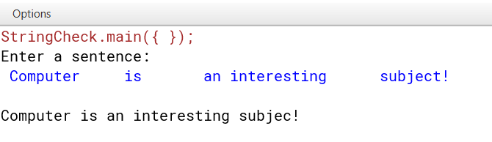

Question 13 :
A simple encryption system uses a shifting process to hide a message. The value of the shift can be in the range 1 to 26. For example a shift of 7 means that A = U, B =V,C = W, etc.i e.
Text : A B C D E F G H I J K L M N O P Q R S T U V W X Y Z
Code: U V W X Y Z A B C D E F G H I J K L M N O P Q R S T
Fist an extra space is added to the end of the string. To make things little more difficult, spaces within the original text are replaced with QQ before the text is encrypted. Double Q (QQ) was selected because no English word ends in Q or contains QQ.
Additionally the coded message is printed in blocks of six characters separated by spaces. The last block might not contain six characters. Write a program that takes the coded text (less than 100 characters), the shift value and prints the decoded original text. Your program must reject any non-valid value for shift and display an error message “INVALID SHIFT VALUE)”. Assume all characters are upper case. Test your program for the following data and some data that you have coded, using the rules given above:
SAMPLE DATA:
1. INPUT:
CODED TEXT : “UHINBY LKKQCH HYLKK”
SHIFT : 7
OUTPUT:
DECODED TEXT : ANOTHER VALUE
2. INPUT:
CODED TEXT : “RUIJGG EVGGBK SAGG”
SHIFT : 11
OUTPUT:
DECODED TEST : BEST OF LUCK
3. INPUT:
CODED TEXT : “DKSMMW NAMMUK QMM”
SHIFT : 29
OUTPUT:
INVALID SHIFT VAULE

Algorithm :
Step 1: Start
Step 2: Read the sentence and store it in ‘str’. Read the word to be deleted and store it in ‘del.
Read the position of the word stored in ‘del’ and store it in ‘pos’.
Step 3: If str does not end with ‘.’, ‘?’ or ‘!’, display “Invalid Input”. Go to Step 16
Step 4: Let str2 = “”
Step 5: str2 += str.charAt(0);
Step 6: Run a loop from i = 0 to i < len (Where len is array length)
Step 7: Let ch = character at ith position
Step 8: If ch == ‘ ‘ and character at i+1th position == ‘ ‘, then ignore Step 9
Step 9: str2 += ch
End Loop
Step 10: convert str2 into a string array arr[]
Step 11: Let len = array length
Step 12: Run a loop from i = pos-1 to i < len-1 (Where i is the Loop Control Variable)
Step 13: arr[i] = arr[i+1]
Step 14: len=len-1
Step 15: Print array
Step 16: End

Source Code :
import java.util.*;
class encryption{
String s,s2="";
int shift;
void accept(){
Scanner in = new Scanner(System.in);
System.out.println("Enter encrypted text and shift value");
s = in.nextLine(); // accepting user input
shift = in.nextInt();
if(shift<1||shift>26){
System.out.println("Invalid shift value");
System.exit(0);
}
}
void decode(){
s = s.replaceAll(" ","");
char c;
for(int i=0;i<s.length();i++){
if(s.charAt(i)+shift-1>90){
c = (char)(s.charAt(i) + (shift - 27)); // decryption
}
else{
c = (char)(s.charAt(i) + (shift - 1)); // decryption
}
s2+=c;
}
s2 = s2.replaceAll("QQ"," ");
System.out.println("Decoded text: " + s2); // Displaying the decoded text
}
public static void main(String args[]){
encryption obj = new encryption(); // creating object
obj.accept(); // calling methods
obj.decode();
}
}

VDT-
VARIABLE NAME | TYPE | PURPOSE
s | String | To store the encoded text
s2 | String | To store the decoded text
shift | int | To store the shift value
c | char | To store a character
i | int | Loop control variable

Question 14 :
Write a program to input a word from the user and remove the consecutive repeated characters by replacing the sequence of repeated characters by its single occurrence.

Algorithm:
Step 1: Start
Step 2: Read the code and store it in ‘str’. Read the shift value and store it in ‘shift’.
Step 3: If string’s length > 100, display “Invalid input”. Go to Step
Step 4: If shift < 1 or shift > 26, display “Invalid input”. Go to Step
Step 5: Let str2 = “”
Step 6: shift = shift -1
Step 7: Run a loop from I = 0 to I < LEN – 1 (Where LEN is string length)
Step 8: Let ch = character at ith position
Step 9: If ch == ‘ ‘, go to Step 7
Step 10: If ch == ‘Q’ and character at i+1th position == ‘Q’, str2 += “ “
Step 11: If Step 10 is not true, then let ascii = (int)ch
Step 12: Let new_ascii = ascii + shift
Step 13: If new_ascii > 90, new_ascii -= 26 and str2+= (char)new_ascii
Step 14: If Step 13 is not true, then str2 += (char)new_ascii
End Loop
Step 15: Display str2
Step 16: End

Source Code:
import java.util.Scanner;
public class RemovingConsecutives
{
public static void main(String[] args)
{
Scanner sc = new Scanner(System.in); System.out.println("Enter the word"); String sen = sc.nextLine();
sen = sen + " "; String newsen = "";
for(int i = 0; i < sen.length()-1;)
{
char c = sen.charAt(i); newsen = newsen + c +""; while(c == sen.charAt(i))
{
i++;
}
}
System.out.println(newsen);
}
}

VDT:

Variable | Datatype | Function
sen | String | Stores the String value
newsen | String | Stores the String value
c | Character | Stores the Character value
i | int | Stores the integer value used in loop

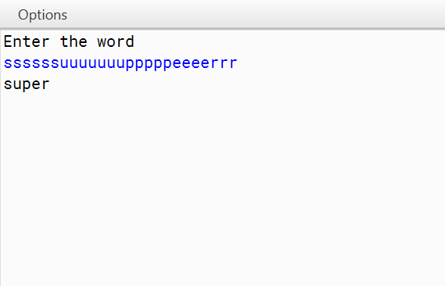
Output:

Question 15 :
Write a program to input a string (word). Convert it into lowercase letters. Count and print the frequency of each alphabet present in the string.

Algorithm:
Step 1: Start
Step 2: Read a word and store it in ‘word’. Convert it to lowercase
Step 3: Let word2 = “”
Step 4: Let flag = false
Step 5: word2 += character at 0th position
Step 5: Run a loop from I = 0 to I < LEN (Where Len is the length of string)
Step 6: Let ch = character at i^{th} position
Step 7: If ch == character at i-1th position then ignore Step 8
Step 8: word2 += ch
End Loop
Step 9: Display word2
Step 10: End

Source Code:
import java.util.Scanner; class RemovingConsecutives
{
public static void main(String[] args)
{
RemovingConsecutives obj = new RemovingConsecutives(); Scanner sc = new Scanner(System.in); System.out.println("Enter the word");
String sen = sc.nextLine(); sen = sen.toLowerCase(); sen = obj.sortedString(sen); String s;
int count = 0; System.out.println("Alphabet\tfrequency");
for(int i = 0; i < sen.length(); i++)//loop to find frequency and then print it
{
char c = sen.charAt(i);
for(int j = 0; j < sen.length(); j++)
{
if(sen.charAt(j) == c && sen.charAt(j)!= ' ')
{
count++;
}
}
if(count > 0)//so that we do not print “ “
{
System.out.println(c+"\t\t"+count);
}
s=c+"";
sen = sen.replace(s," ");//so that we do not print the same alphabet count = 0;
}
}
String sortedString(String s)//Sorting the string but maintaining its frequency
{
String ns = ""; int pos = 0;
char tmp, small;
char c[] = new char[s.length()]; for(int i =0; i < s.length(); i++)
{
c[i] = s.charAt(i);
}
for(int i = 0; i < c.length; i++)//Selection sort
{
small = c[i];
for(int j = i+1; j < c.length; j++)
{
if(c[j] < small)
{
small = c[j]; pos = j;
}
}
tmp = c[i]; c[i] = c[pos]; c[pos] = tmp;
}
for(int i = 0; i < s.length(); i++)
{
ns = ns+c[i];
}
return ns;
}
}

VDT:

Variable | Datatype | Function
sen | String | Stores the String value
s | String | Stores the String value of the character
count | String | Stores the integer value
i | int | Stores the integer value used in loop
tmp | char | Stores the Character value
pos | int | Stores the integer value
small | char | Stores the Character value
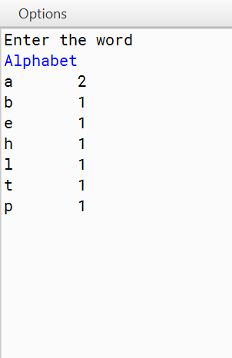
Output
DATA STRUCTURE PROGRAMS :
Question 16 :
Write a program to implement Stack with pop(), push() and print() methods.

Algorithm:

ALGORITHM FOR POP IN STACK:

STEP 1: START
STEP 2: IF TOP < 0 then STACK UNDERFLOW, exit
Else
STEP 3: VALUE = STACK[TOP]
STEP 4: TOP=TOP - 1
STEP 4: END

ALGORITHM FOR PUSH IN STACK:

STEP 1: START
STEP 2: IF TOP = CAPACITY then STACK OVERFLOW, exit
Else
STEP 3: TOP = TOP +1
STEP 4: STACK[TOP] = VALUE
STEP 5: END

ALGORITHM FOR PRINTING ELEMENTS :
STEP 1 : START
STEP 2 : RUN A LOOP FROM i=1 to i=length of array
STEP 3: PRINT ELEMEMNTS
STEP 4 : STOP

Source Code:
public class Stack//Stack class
{
int ST[]; int size; int top;
Stack(int n)//Parameterised Constructor
{
size = n;
ST = new int[size]; top = -1;
}
void push(int n)//Push an element from rear
{
if(top == size - 1)
{
System.out.print("Overflow");
}
else
{
top = top + 1; ST[top] = n;
}
}
void pop()//Delete an element from rear
{
if(top == -1)
{
System.out.print("Underflow");
}
else
{
top = top - 1;
}
}
void peep()//Displays an element from end
{
if(top == -1)
{
System.out.print("Underflow");
}
else
{
System.out.println(ST[top]);
}
}
}

VDT:

Variable | Datatype | Function
ST | int[] | Stores the integers in array
size | int | Stores the length of array
top | int | Stores integral value
n | int | Stores integral value

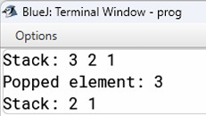
Output:

Question 17 :
Write a program to implement LinearQ with insert(), delete() and print() methods.
ALGORITHM FOR PUSH (INSERTION) IN LINEAR QUEUE:

STEP 1: START
STEP 2: IF REAR = CAPACITY then QUEUE OVERFLOW, exit
Else
STEP 3: REAR = REAR +1
STEP 4: QUEUE[REAR] = VALUE
STEP 5: END

ALGORITHM FOR POP (DELETION) IN LINEAR QUEUE:

STEP 1: START
STEP 2: IF FRONT=REAR then QUEUE UNDERFLOW, exit
Else
STEP 3: FRONT=FRONT + 1
STEP 4: VALUE = QUEUE[FRONT]
STEP 4: END

ALGORITHM FOR PRINTING ELEMENTS :
STEP 1 : START
STEP 2 : RUN A LOOP FROM i=1 to i=length of array
STEP 3: PRINT ELEMENTS
STEP 4 : STOP

Source Code:
class Queue
{
int Q[]; int size;
int front, rear;
Queue(int n)//Parameterised Constructor
{
size = n;
Q = new int[size]; rear = -1;
front = -1;
}
void enqueue(int n)//Add element from rear
{
if(rear == size - 1)
{
System.out.print("Overflow");
}
else if(rear == -1 && front == -1)
{
front++; Q[++rear] = n;
}
else
{
Q[++rear] = n;
}
}
void dequeue()//Add element from front
{
if(rear == -1 && front == -1)
{
System.out.print("Underflow");
}
else if(rear == front)
{
front = -1;
rear = -1;
}
else
{
front++;
}
}
void display()//Display last element
{
if(front == -1 && rear == -1)
{
System.out.println("Empty Queue");
}
else
{
for(int i = front; i <= rear; i++)
{
System.out.print(Q[i]);
}
}
}
}

VDT:

Variable | Datatype | Function
Q | int[] | Stores the integers in array
size | int | Stores the length of array
front | int | Stores integral value
rear | int | Stores integral value
n | int | Stores integral value
x | int | Stores integral value

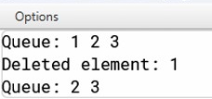
Output:

Question 18 :
Write a program to implement Dequeue with insertfront(), insertRear(), deleteFront(), deleteRear() and print() methods.

Algorithm:
ALGORITHM FOR PUSH FROM FRONT IN DEQUEUE:

STEP 1: START
STEP 2: IF FRONT = 0 then QUEUE OVERFLOW FROM FRONT, exit
Else
STEP 3: QUEUE[FRONT] = VALUE
STEP 4: FRONT=FRONT-1
STEP 5: END

ALGORITHM FOR POP FROM FRONT IN DEQUEUE:

STEP 1: START
STEP 2: IF FRONT=REAR then QUEUE UNDERFLOW FROM FRONT, exit
Else
STEP 3: FRONT=FRONT+1
STEP 4: VALUE = QUEUE[FRONT]
STEP 5: END

ALGORITHM FOR PUSH FROM REAR IN DEQUEUE:

STEP 1: START
STEP 2: IF REAR = CAPACITY then QUEUE OVERFLOW FROM REAR, exit
Else
STEP 3: REAR = REAR +1
STEP 4: QUEUE[REAR] = VALUE
STEP 5: END

ALGORITHM FOR POP FROM REAR IN DEQUEUE:

STEP 1: START
STEP 2: IF FRONT=REAR then QUEUE UNDERFLOW FROM REAR, exit
Else
STEP 3: VALUE = QUEUE[FRONT]
STEP 4: REAR=REAR-1
STEP 4: END

Source Code:
public class Deque
{
int Q[]; int size;
int front, rear;
Deque(int n) //Parameterised Constructor
{
size = n;
Q = new int[size]; rear = -1;
front = -1;
}
void enqueue_front(int n) //Add element from front
{
if(front == 0 )
{
System.out.print("Underflow");
}
else
{
Q[front--] = n;
}
}
void enqueue_back(int n)//Add element from rear
{
if(rear == size - 1)
{
System.out.print("Overflow");
}
else if(rear == -1 && front == -1)
{
front++; Q[++rear] = n;
}
else
{
Q[++rear] = n;
}
}
void dequeue_front()//Remove Element from front
{
if(rear == -1 && front == -1)
{
System.out.print("Underflow");
}
else if(rear == front)
{
front = -1;
rear = -1;
}
else
{
front++;
}
}
void dequeue_back()//Remove Element from back
{
if(rear == -1 && front == -1)
{
System.out.print("Underflow");
}
else if(rear == front)
{
front = -1;
rear = -1;
}
else
{
rear--;
}
}
void display()
{
if(front == -1 && rear == -1)
{
System.out.println("Empty Queue");
}
else
{
for(int i = front; i <= rear; i++)
{
System.out.print(Q[i]);
}
}
}
}

VDT:

Variable | Datatype | Function
Q | int[] | Stores the integers in array
size | int | Stores the length of array
front | int | Stores integral value
rear | int | Stores integral value
n | int | Stores integral value
x | int | Stores integral value
y | int | Stores integral value
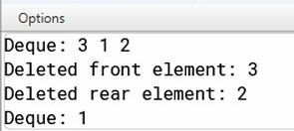
Output :
Question 19 :
Write a program to implement CircularQ with insert(), delete() and print() methods.

Algorithm:

ALGORITHM FOR PUSH (INSERTING)IN CIRCULAR QUEUE:

STEP 1: START
STEP 2: IF FRONT = (REAR+1) MOD CAPACITY then QUEUE OVERFLOW, exit
Else
STEP 3: REAR = (REAR +1) MOD CAPACITY
STEP 4: QUEUE[REAR] = VALUE
STEP 5: END

ALGORITHM FOR POP (DELETING) IN CIRCULAR QUEUE:

STEP 1: START
STEP 2: IF FRONT=REAR then QUEUE UNDERFLOW, exit
Else
STEP 3: FRONT=(FRONT + 1) MOD CAPACITY
STEP 4: VALUE = QUEUE[FRONT]
STEP 4: END

Source Code:
public class CircularQueue { int[] queue;
int size;
int front, rear, count;

// Constructor to initialize the queue public CircularQueue(int n) {
size = n;
queue = new int[size]; front = 0;
rear = -1;
count = 0;
}

// Method to insert an element into the queue public void insert(int n) {
if (isFull()) {
System.out.println("Queue is full. Cannot insert " + n);
} else {
rear = (rear + 1) % size; // Circular increment queue[rear] = n;
count++; System.out.println("Inserted " + n);
}
}

// Method to delete an element from the queue public void delete() {
if (isEmpty()) {
System.out.println("Queue is empty. Cannot delete.");
} else {
System.out.println("Deleted " + queue[front]); front = (front + 1) % size; // Circular increment count--;
}
}

// Method to print all elements in the queue public void print() {
if (isEmpty()) { System.out.println("Queue is empty.");
} else {
System.out.print("Queue elements: "); int i = front;
for (int j = 0; j < count; j++) { System.out.print(queue[i] + " ");
i = (i + 1) % size; // Circular increment
}
System.out.println();
}
}

// Check if the queue is full private boolean isFull() {
return count == size;
}

// Check if the queue is empty private boolean isEmpty() {
return count == 0;
}

// Main method to test the CircularQueue public static void main(String[] args) {
CircularQueue cq = new CircularQueue(5); // Creating a circular queue of size 5

cq.insert(10); cq.insert(20); cq.insert(30); cq.insert(40); cq.insert(50);
cq.print(); // Output: Queue elements: 10 20 30 40 50 cq.delete();
cq.delete();
cq.print(); // Output: Queue elements: 30 40 50 cq.insert(60);
cq.insert(70);

cq.print(); // Output: Queue elements: 30 40 50 60 70
}
}

VDT:

Variable | Datatype | Function
Q | int[] | Stores the integers in array
size | int | Stores the length of array
front | int | Stores integral value
rear | int | Stores integral value
count | int | Stores integral value
n | int | Stores integral value
x | int | Stores integral value
j | int | Stores integral value

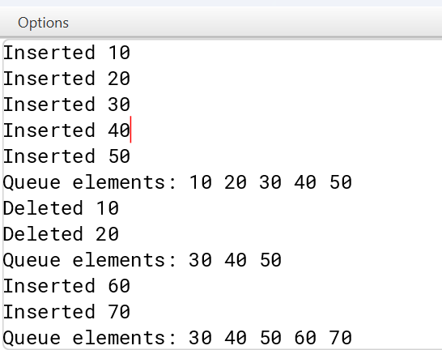
Output:

Question 20 :
Write a program to implement Linked List
Algorithm:
Insertion at the beginning
- Create a new node and allocate memory for it.
- Point the new node's next pointer to the current head of the list.
- Update the head of the list to point to the new node.
Insertion at the end
- Create a new node and allocate memory for it.
- Traverse the list until you reach the last node.
- Set the last node's next pointer to the new node.
Insertion at the middle
- Create a new node and allocate memory for it.
- Traverse the list until you reach the node just before the desired position.
- Adjust the pointers:
- Point the new node’s next to the next node of the current node.
- Point the current node’s next to the new node.
Deletion from beginning
- If the list is empty, do nothing or return an appropriate message.
- Point the head of the list to the next node.

Deletion from the middle
- If the list is empty or the position is invalid, do nothing or return an appropriate message.
- Traverse the list until you reach the node just before the desired position.
- Adjust the pointers:

Deletion from the end
- If the list is empty, do nothing or return an appropriate message.
- If there is only one node, delete it and set the head to null.
- Traverse the list until you reach the second-to-last node.
- Set the second-to-last node’s next pointer to null.
Source Code :
import java.io.*;

// Java program to implement
// a Singly Linked List
public class LinkedList {
Node head; // head of list
static class Node {
int data;
Node next;
// Constructor
Node(int d)
{
data = d;
next = null;
}
}
// Method to insert a new node
public static LinkedList insert(LinkedList list,int data)
{
// Create a new node with given data
Node new_node = new Node(data);
new_node.next = null;

// If the Linked List is empty,
// then make the new node as head
if (list.head == null) {
list.head = new_node;
}
else {
// Else traverse till the last node
// and insert the new_node there
Node last = list.head;
while (last.next != null) {
last = last.next;
}

// Insert the new_node at last node
last.next = new_node;
}

// Return the list by head
return list;
}

// **************TRAVERSAL**************

// Method to print the LinkedList.
public static void printList(LinkedList list)
{
Node currNode = list.head;

System.out.print("\nLinkedList: ");

// Traverse through the LinkedList
while (currNode != null) {
// Print the data at current node
System.out.print(currNode.data + " ");

// Go to next node
currNode = currNode.next;
}
System.out.println("\n");
}

// **************DELETION BY KEY**************

// Method to delete a node in the LinkedList by KEY
public static LinkedList deleteByKey(LinkedList list,int key)
{
// Store head node
Node currNode = list.head, prev = null;

//
// CASE 1:
// If head node itself holds the key to be deleted

if (currNode != null && currNode.data == key) {
list.head = currNode.next; // Changed head

// Display the message
System.out.println(key + " found and deleted");

// Return the updated List
return list;
}

//
// CASE 2:
// If the key is somewhere other than at head
//

// Search for the key to be deleted,
// keep track of the previous node
// as it is needed to change currNode.next
while (currNode != null && currNode.data != key) {
// If currNode does not hold key
// continue to next node
prev = currNode;
currNode = currNode.next;
}

// If the key was present, it should be at currNode
// Therefore the currNode shall not be null
if (currNode != null) {
// Since the key is at currNode
// Unlink currNode from linked list
prev.next = currNode.next;

// Display the message
System.out.println(key + " found and deleted");
}

//
// CASE 3: The key is not present
//

// If key was not present in linked list
// currNode should be null
if (currNode == null) {
// Display the message
System.out.println(key + " not found");
}

// return the List
return list;
}

// **************DELETION AT A POSITION**************

// Method to delete a node in the LinkedList by POSITION
public static LinkedList
deleteAtPosition(LinkedList list, int index)
{
// Store head node
Node currNode = list.head, prev = null;

//
// CASE 1:
// If index is 0, then head node itself is to be
// deleted

if (index == 0 && currNode != null) {
list.head = currNode.next; // Changed head

// Display the message
System.out.println(
index + " position element deleted");

// Return the updated List
return list;
}

//
// CASE 2:
// If the index is greater than 0 but less than the
// size of LinkedList
//
// The counter
int counter = 0;

// Count for the index to be deleted,
// keep track of the previous node
// as it is needed to change currNode.next
while (currNode != null) {

if (counter == index) {
// Since the currNode is the required
// position Unlink currNode from linked list
prev.next = currNode.next;

// Display the message
System.out.println(
index + " position element deleted");
break;
}
else {
// If current position is not the index
// continue to next node
prev = currNode;
currNode = currNode.next;
counter++;
}
}

// If the position element was found, it should be
// at currNode Therefore the currNode shall not be
// null
//
// CASE 3: The index is greater than the size of the
// LinkedList
//
// In this case, the currNode should be null
if (currNode == null) {
// Display the message
System.out.println(
index + " position element not found");
}

// return the List
return list;
}

// **************MAIN METHOD**************

// method to create a Singly linked list with n nodes
public static void main(String[] args)
{
/* Start with the empty list. */
LinkedList list = new LinkedList();

//
// ******INSERTION******
//

// Insert the values
list = insert(list, 1);
list = insert(list, 2);
list = insert(list, 3);
list = insert(list, 4);
list = insert(list, 5);
list = insert(list, 6);
list = insert(list, 7);
list = insert(list, 8);

// Print the LinkedList
printList(list);
// DELETION BY KEY
// Delete node with value 1
// In this case the key is ***at head***
deleteByKey(list, 1);

// Print the LinkedList
printList(list);

// Delete node with value 4
// In this case the key is present in the middle
deleteByKey(list, 4);

// Print the LinkedList
printList(list);

// Delete node with value 10
// In this case the key is not present
deleteByKey(list, 10);

// Print the LinkedList
printList(list);

//
// DELETION AT POSITION
//

// Delete node at position 0
// In this case the key is at head
deleteAtPosition(list, 0);

// Print the LinkedList
printList(list);

// Delete node at position 2
// In this case the key is present in the middle
deleteAtPosition(list, 3);

// Print the LinkedList
printList(list);

// Delete node at position 10
// In this case the key is ***not present***
deleteAtPosition(list, 9);

// Print the LinkedList
printList(list);
}
}

VDT :
Data Type | Variable Name | Description
Node (Object) | head | Head of list
Node | new_node | New Node to be inserted
Node | currNode | Current node to be printed

Output :
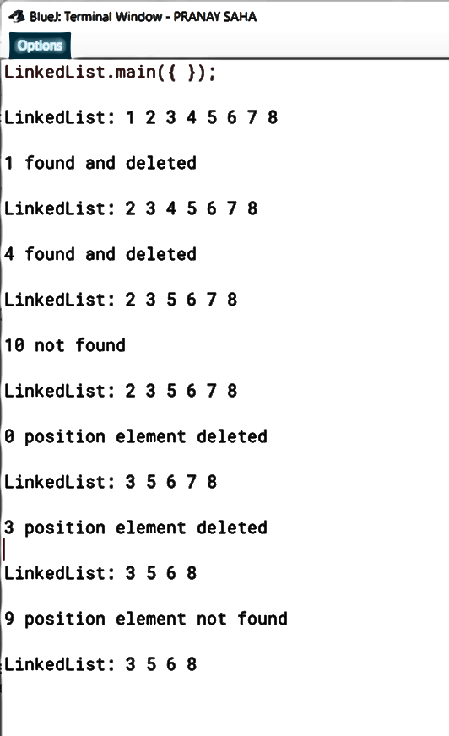
Question 21 :

Write a program to Implement Stack using Linked List.

Algorithm for Push Operation:
Step 1: Create a new node.
Step 2: Set the data of the new node to the value to be pushed.
Step 3: Set the next pointer of the new node to the current top node.
Step 4: Update the top pointer to point to the new node.

Algorithm for Pop Operation:
Step 1: Check if the stack is empty (i.e., top == null). If it is empty, return an error or message indicating underflow.
Step 2: Store the data of the top node in a temporary variable.
Step 3: Update the top pointer to point to the next node in the stack.
Step 4: Return the stored data.

Source Code :
class Node {
int data; // Data stored in the node
Node next; // Pointer to the next node

// Constructor to initialize node data
public Node(int data) {
this.data = data;
this.next = null;
}
}

import java.util.*;
class Stack_Link {
private Node top; // Pointer to the top element of the stack

// Constructor to initialize the stack
public Stack_Link() {
this.top = null; // Stack is initially empty
}

// Method to push an element onto the stack
public void push(int data) {
Node newNode = new Node(data); // Create a new node with the given data
newNode.next = top; // Point the new node to the current top
top = newNode; // Update the top to the new node
System.out.println(data + " pushed onto the stack.");
}

// Method to pop an element from the stack
public int pop() {
if (isEmpty()) {
System.out.println("Stack underflow! Cannot pop from an empty stack.");
return -1; // Return -1 to indicate that the stack is empty
}
int poppedData = top.data; // Retrieve data from the top node
top = top.next; // Update the top to the next node
System.out.println(poppedData + " popped from the stack.");
return poppedData;
}

// Method to check if the stack is empty
public boolean isEmpty() {
return top == null;
}

// Method to print the elements of the stack
public void print() {
if (isEmpty()) {
System.out.println("The stack is empty.");
return;
}
Node current = top;
System.out.print("Stack elements: ");
while (current != null) {
System.out.print(current.data + " ");
current = current.next;
}
System.out.println();
}

public static void main(String[] args) {
Scanner scanner = new Scanner(System.in);
Stack_Link stack = new Stack_Link(); // Create a new stack

boolean exit = false;
while (!exit) {
System.out.println("\nChoose an operation:");
System.out.println("1. Push");
System.out.println("2. Pop");
System.out.println("3. Print");
System.out.println("4. Exit");
System.out.print("Your choice: ");
int choice = scanner.nextInt();

switch (choice) {
case 1:
System.out.print("Enter a value to push onto the stack: ");
int value = scanner.nextInt();
stack.push(value);
break;
case 2:
stack.pop();
break;
case 3:
stack.print();
break;
case 4:
exit = true;
System.out.println("Exiting program.");
break;
default:
System.out.println("Invalid choice! Please try again.");
break;
}
}

scanner.close();
}
}

VARIABLE DESCRIPTION TABLE
Variable name | Datatype | Description
Top | Node | To point the topmost node
current | Node | To point the current node
Exit | Boolean | Checks the status

OUTPUT :
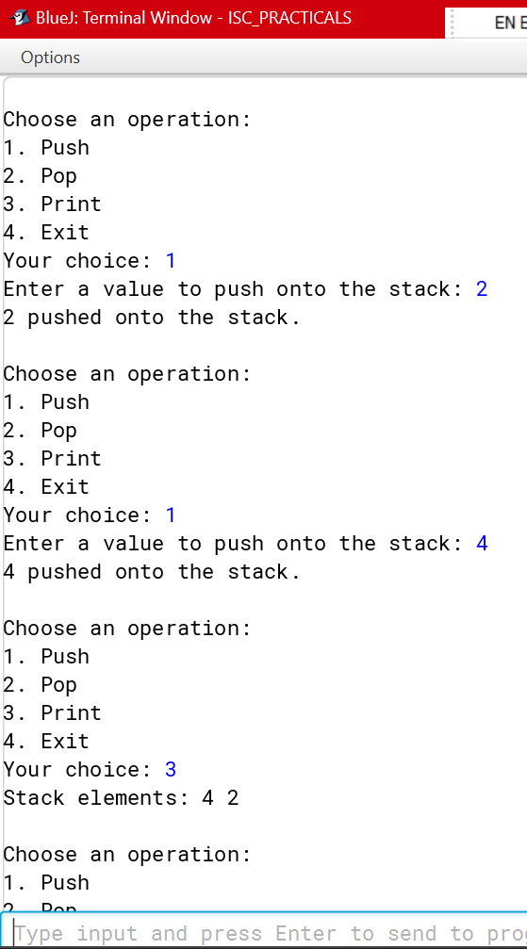

Question 22 :

Write a program to Implement Queue using Linked List.

Algorithm to Insert element:
Step 1: Create a new node.
Step 2: Set the data of the new node to the value to be enqueued.
Step 3: If the queue is empty (i.e., rear == null), set both front and rear to the new node.
Step 4: If the queue is not empty, set the next pointer of the current rear node to the new node, then update the rear pointer to the new node.

Algorithm to Delete element:
Step 1: If the queue is empty (i.e., front == null), return an error or message indicating underflow.
Step 2: Store the data of the front node in a temporary variable.
Step 3: Update the front pointer to point to the next node in the queue.
Step 4: If the front becomes null after this operation (i.e., the queue is now empty), set rear to null as well.
Step 5: Return the stored data.

Source Code:

class Node {
int data; // Data stored in the node
Node next; // Pointer to the next node

// Constructor to initialize node data
public Node(int data) {
this.data = data;
this.next = null;
}
}

// Queue class using a linked list
import java.util.*;
class Queue_Link {
private Node front; // Pointer to the front of the queue
private Node rear; // Pointer to the rear of the queue

// Constructor to initialize the queue
public Queue_Link() {
this.front = null; // Queue is initially empty
this.rear = null; // Queue is initially empty
}

// Method to add an element to the rear of the queue
public void enqueue(int data) {
Node newNode = new Node(data); // Create a new node with the given data
if (rear == null) { // If the queue is empty
front = newNode; // The new node becomes the front
rear = newNode; // The new node also becomes the rear
} else {
rear.next = newNode; // Link the new node at the end of the queue
rear = newNode; // Update the rear to the new node
}
System.out.println(data + " enqueued into the queue.");
}

// Method to remove an element from the front of the queue
public int dequeue() {
if (isEmpty()) {
System.out.println("Queue underflow! Cannot dequeue from an empty queue.");
return -1; // Return -1 to indicate that the queue is empty
}
int dequeuedData = front.data; // Retrieve data from the front node
front = front.next; // Update the front to the next node

if (front == null) { // If the queue becomes empty after dequeue
rear = null; // Update rear to null
}

System.out.println(dequeuedData + " dequeued from the queue.");
return dequeuedData;
}

// Method to check if the queue is empty
public boolean isEmpty() {
return front == null;
}

// Method to print the elements of the queue
public void print() {
if (isEmpty()) {
System.out.println("The queue is empty.");
return;
}
Node current = front;
System.out.print("Queue elements: ");
while (current != null) {
System.out.print(current.data + " ");
current = current.next;
}
System.out.println();
}

public static void main(String[] args) {
Scanner scanner = new Scanner(System.in);
Queue_Link queue = new Queue_Link(); // Create a new queue

boolean exit = false;
while (!exit) {
System.out.println("\nChoose an operation:");
System.out.println("1. Enqueue");
System.out.println("2. Dequeue");
System.out.println("3. Print");
System.out.println("4. Exit");
System.out.print("Your choice: ");
int choice = scanner.nextInt();

switch (choice) {
case 1:
System.out.print("Enter a value to enqueue into the queue: ");
int value = scanner.nextInt();
queue.enqueue(value);
break;
case 2:
queue.dequeue();
break;
case 3:
queue.print();
break;
case 4:
exit = true;
System.out.println("Exiting program.");
break;
default:
System.out.println("Invalid choice! Please try again.");
break;
}
}

scanner.close();
}
}

VARIABLE DESCRIPTION TABLE
Variable name | Datatype | Description
Front | Node | To point the first node
Rear | Node | To point the last node
Newnode | Node | To store the node temporary
Exit | Boolean | Checks the status

OUTPUT :
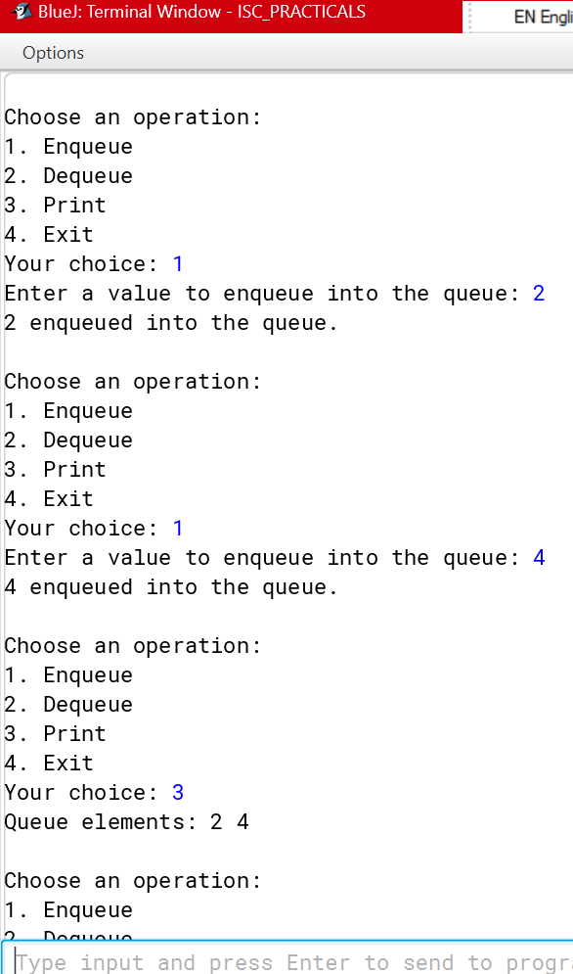

Question 23 :
A class Employee contains employee details and another class Salary calculates the employee’s net salary. The details of the two classes are given below:
Class name : Employee
Data members :
empNo : stores the employee number.
empName : stores the employee name
empDesig : stores the employee’s designation. Member functions:
Employee() : default constructor.
Employee(…) : parameterized constructor to assign values to data members.
void display() : display the employee details.

Class name : Salary Data members :
basic : float variable to store the basic pay. Member functions :
Salary(…) : parameterized constructor to assign values to data members.
void calculate() : calculates the employee’s net salary according to the
following rules:
DA = 10% of basic HRA = 15% of basic
Salary = basic + DA +H RA PF= 8 % of Salary
Net Salary = Salary –PF
Display the employee details and the Net salary.

Specify the class Employee giving details of the constructors and member function void display(). Using the concept of inheritance specify the class Salary giving details of the constructor and the member function void calculate(). The main function need not be written.

Algorithm:
STEP 1: START
STEP 2: Define a class named Employee as the super class.
STEP 3: Declare instance variables empNo (int), empName (String), and empDesig (String).
STEP 4: Implement a default constructor to initialize empNo, empName, and empDesig to default values. STEP 5: Implement a parameterized constructor to initialize empNo, empName, and empDesig with provided values.
STEP 6: Implement a method display() to display empNo, empName, and empDesig. STEP 7: Define a class named Salary as a subclass of Employee.
STEP 8: Declare an instance variable basic (double).
STEP 9: Implement a parameterized constructor to initialize basic and call the superclass constructor to initialize empNo, empName, and empDesig.
STEP 10: Implement a method calculate() to calculate and display the net salary. STEP 11: STOP

Source Code:
public class Employee//Super Class
{
int empNo;
String empName, empDesig; Employee() //Parameterised Constructor
{
empNo = 0; empName = ""; empDesig = "";
}
Employee(int N, String Na, String De) //Parameterised Constructor
{
empNo = N; empName = Na; empDesig = De;
}
void display()//Display method
{
System.out.println("Employee number: "+empNo); System.out.println("Employee name: "+empName); System.out.println("Employee Designation: "+empDesig);
}
}
class Salary extends Employee //Sub class
{
double basic;
Salary(double b, int empNo, String empName, String empDesig) //Parameterised Constructor
{
super(empNo,empName, empDesig); basic = b;
}
void calculate() //Method to calculate
{
double DA = basic * (10/100); double HRA = basic * (15/100); double Salary = basic + DA + HRA; double PF = Salary * (8/100); double Net_Salary = Salary - PF; super.display();
System.out.println("Basic Salary: "+basic); System.out.println("Net Salary: "+Net_Salary);
}
}

VDT:

Variable Name | Datatype | Function
empNo | int | Stores integral Value
empName | String | Stores StringValue
empDesig | String | Stores String Value
DA | double | Stores Double Value
HRA | double | Stores Double Value
Salary | double | Stores Double Value
PF | double | Stores Double Value
Net_Salary | double | Stores Double Value

Output:

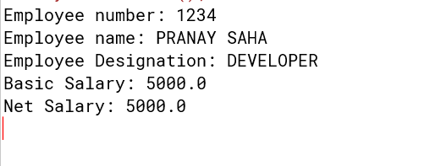
Question 24:
A super class Worker has been defined to store the details of a worker. Define a sub class Wages to compute the monthly wages for the worker. The details of both the classes are given below:
Class name : Worker
Data members :
name : to store the name of the worker
basic : to store the basic pay in decimal Member functions :
Worker(….) : parameterized constructor to assign values to the instance variables
void display() : display worker details

Class name : Wages Data members :
hrs : stores the hours worked
rate : stores rate per hour
wage : stores the overall wage of the worker Member functions
Wages(….) : parameterized constructor to assign values to the instance variables of both classes
double overtime( ) : calculates and returns the overtime amount as (hours * rate )
void display() : calculates the wage using the formula wage=overtime amount + basic pay and displays along with other details

Specify the class Worker giving details of the constructor() and void display(). Using the concept of inheritance, specify the class Wages giving details of the constructor(), double overtime() and void display(). The main function need not be written.

Algorithm:
STEP 1: START
STEP 2: Define a class named Worker as the super class.
STEP 3: Declare instance variables name (String) and basic (double).
STEP 4: Implement a parameterized constructor to initialize name and basic with provided values. STEP 5: Implement a method display() to display name and basic.
STEP 6: Define a class named Wages as a subclass of Worker.
STEP 7: Declare instance variables hrs (int), wage (double), and rate (double).
STEP 8: Implement a parameterized constructor to initialize name, basic, hrs, wage, and rate and call the superclass constructor to initialize name and basic.
STEP 9: Implement a method overtime() to calculate overtime.
STEP 10: Implement a method display() to display name, basic, overtime, and total wage. STEP 11: STOP

Source Code:
public class Worker//Super Class
{
String name; double basic;
Worker(String n, double b)//Parameterised Constructor
{
name = n; basic = b;
}
void display()//Display Method
{
System.out.println("Name: "+name); System.out.println("Basic Pay: "+basic);
}
}
class Wages extends Worker//Sub Class
{
int hrs;
double wage, rate;
Wages(String n, double b, int h, double w, double r)//Parameterised Constructor
{
super(n,b); hrs = h; wage = w; rate = r;
}
double overtime()//Calculates overtime
{
return hrs*rate;
}
void display()//Display Method
{
wage = overtime()+super.basic; super.display(); System.out.println("Overtime: "+ overtime()); System.out.println("Wages: "+ wage);
}
}

VDT:

Variable Name | Datatype | Function
name | String | Stores String Value
basic | double | Stores Doube Value
hrs | int | Stores Integral Value
rate | double | Stores Double Value
wage | double | Stores Double Value
Output:

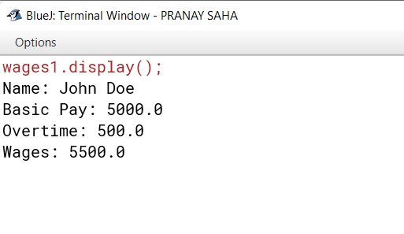

Question 25 :
A super class Record has been defined to store the names and ranks of 50 students. Define a sub class Rank to find the highest rank along with the name. The details of both classes are given below:
Class name : Record

Data members
name[] : to store the names of students
rnk[] : to store the ranks of students Member functions :
Record() : constructor to initialize data members void readvalues() : to store names and ranks
void display() : displays the names and the corresponding ranks

Class name : Rank Data members
index : integer to store the index of the topmost rank Member functions
Rank() : constructor to invoke the base class constructor and to initialize index to 0.
void highest() : finds the index location of the topmost rank and stores it in index without sorting the array
void display() : displays the name and ranks along with the name having the topmost rank.
Specify the class Record giving details of the constructor(), void readvalues(), void display(). Using the concept of inheritance, specify the class Rank giving details of constructor(), void highest() and void display(). The main function and algorithm need not be written.

Algorithm:
STEP 1: START
STEP 2: DEFINE the `Record` class.
STEP 3: DECLARE data members `name` (array of Strings) and `rnk` (array of integers). STEP 4: DEFINE the constructor `Record()` to initialize `name` and `rank`.
STEP 5: DEFINE the method `readvalues()` to read input values. STEP 6: DEFINE the method `display()` to print all names and ranks. STEP 7: DEFINE the `Rank` class that extends `Record`.
STEP 8: DECLARE data member `index`.
STEP 9: DEFINE the constructor `Rank()` to initialize `index` and call the superclass constructor. STEP 10: DEFINE the method `highest()` to find the highest rank.
STEP 11: OVERRIDE the method `display()` in `Rank` to display the highest rank. STEP 12: DEFINE the `main` method to create an instance of `Rank`.
STEP 13: CALL the `readvalues()` method to input values. STEP 14: CALL the `highest()` method to find the highest rank. STEP 15: CALL the `display()` method to display the results.
STEP 16: STOP

Source Code:
import java.util.Scanner;
public class Record//Super Class
{
String name[]; int rnk[]; Record()
{
name = new String [10]; rnk = new int[10];
}
void readvalues()//Read or takes input
{
Scanner sc = new Scanner(System.in); for(int i = 0; i < 10; i++)
{
System.out.println("Enter name: "); name[i] = sc.nextLine(); System.out.println("Enter rank: "); rnk[i] = sc.nextInt();
}
}
void display()//Display method
{
for(int i = 0; i < 10; i++)
{
System.out.println(name[i]+": "+rnk[i]);
}
}
}
class Rank extends Record//Sub class
{
int index; Rank()
{
super(); index = 0;
}
void highest()//Finds Rank
{
index = 0;
int c = rnk[0];
for(int i = 0; i < 9; i++)
{
if(c > rnk[i+1])
{
index = i+1; c = rnk[i+1];
}
}
}
void display()//Display Method
{
super.display();
System.out.println(name[index]+": "+rnk[index]+" has got the highest");}}

VDT:

Variable Name | Datatype | Function
name[] | String[] | Stores String Value
rank[] | String[] | Stores String Value
index | int | Stores Integer Value

Output:

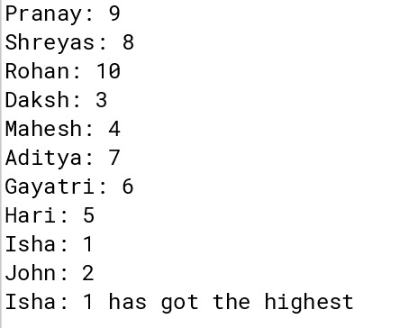

Question 26 :
A super class Detail has been defined to store the details of a customer. Define a sub class Bill to compute the monthly telephone charge of the customer as per the chart given below:

NUMBER OF CALLS RATE
1- 100 Only rental charge
101-200 60 paisa per call + rental charge
201-300 80 paisa per call + rental charge
Above 300 1 rupee per call + rental charge

The details of both the classes are given below:

Class Name : Detail Data members
name : to store the name of the customer.
address : to store the address of the customer.
telno : to store the phone number of the customer.
rent : to store the monthly rental charge
Member functions :
Detail(..) : parameterized constructor to assign values to data members.
void show() : to display the detail of the customer.

Class Name : Bill Data members
n : to store the number of calls.
amt : to store the amount to be paid by the customer.
Member functions :
Bill(..) : parameterized constructor to assign values to data members of both classes and to initialize amt = 0.0.
void cal() : calculates the monthly telephone charge as per the charge given above.
void show() : to display the detail of the customer and amount to be paid.

Specify the class Detail giving details of the constructor( ) and void show(). Uisng the concept of inheritance, specify the class Bill giving details of the constructor( ), void cal() and void show().

Algorithm:

STEP 1: START
STEP 2: DEFINE the `Detail` class.
STEP 3: DECLARE data members `name`, `address`, `telno`, and `rent`.
STEP 4: DEFINE the constructor `Detail(int t, double r, String n, String a)` to initialize the data members. STEP 5: DEFINE the method `show()` to display details.
STEP 6: DEFINE the `Bill` class that extends `Detail`. STEP 7: DECLARE data members `n` and `amt`.
STEP 8: DEFINE the constructor `Bill(int N, int t, double r, String na, String a)` to initialize data members and call the superclass constructor.
STEP 9: DEFINE the method `cal()` to calculate the amount based on usage. STEP 10: DEFINE the method `show()` to display bill details including amount STEP 11: DEFINE the `Main` class with the `main` method.
STEP 12: CREATE an instance of `Bill` class (`det1`) with sample values. STEP 13: CALL the `show()` method on `det1` to display the bill details. STEP 14: STOP

Source Code:
public class Detail//Super Class
{
String name, address; int telno;
double rent;
Detail(int t, double r, String n, String a)//Parameterised Constructor
{
telno = t; rent = r; name = n; address = a;
}
void show()//Display Method
{
System.out.println("Name: "+name); System.out.println("Address: "+address); System.out.println("Telephone No: "+telno); System.out.println("Rent: "+rent);
}
}
class Bill extends Detail//Sub class
{
int n; double amt;
Bill(int N, int t, double r, String na, String a)//Parameterised constructor
{
super(t,r,na,a); n = N;
amt = 0.0;
}
void cal()//Calculate amount
{
if(n <= 100 && n >= 1)
{
amt = super.rent;
}
if(n <= 200 && n >= 101)
{
amt = super.rent + 0.60*n;
}
if(n <= 300 && n >= 201)
{
amt = super.rent + 0.80*n;
}
if(n >= 301)
{
amt = super.rent + 1.00*n;
}
}
void show()//Display Method
{
super.show(); System.out.println("Amount: "+amt);
}
}
class Main//Main Class
{
public static void main()
{
Bill det1 = new Bill(1000,888292876,200.00,"Sam","Diagon Alley"); det1.show();
}
}

VDT:

Variable Name | Datatype | Function
name | String | Stores String Value
address | String | Stores String Value
amt | double | Stores Double Value
rent | double | Stores Double Value
n | int | Stores integral Value
tellno | int | Stores integral Value

Output:

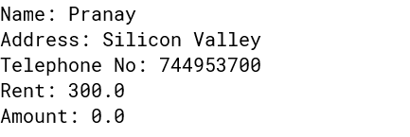

Question 27 :
A super class Perimeter has been defined to calculate the perimeter of a parallelogram. Define a sub class Area to compute the area of the parallelogram by using the required data members of the super class. The details are given below:
Class name : Perimeter Data Members
- : to store the length in decimal
- : to store the breadth in decimal
Member functions :
Perimeter(…) : parameterized constructor to assign values to data members double Calculate() : calculate and return the perimeter of a parallelogram as
2 *(length +breadth)
void show() : to display the data members along with the perimeter of the
parallelogram.

Class name : Area Data Members
h : to store the height in decimal
area : to store the area of the parallologram
Member functions :
Area(…) : parameterized constructor to assign values to data members of both classes.
void doArea() : computes the area( breadth * height).
void show() : to display the data members of both the classes along with the
area and perimeter of the parallelogram.

Specify the class Perimeter giving details of the constructor(…), double Calculate() and void show(). Using the concept of inheritance, specify the class Area giving details of the constructor(…), void doArea() and void show(). The main function and algorithm need not be written.

Algorithm:
STEP 1: START
STEP 2: DEFINE the `Perimeter` class.
STEP 3: DECLARE data members `a` and `b`.
STEP 4: DEFINE the constructor `Perimeter(double A, double B)` to initialize `a` and `b`. STEP 5: DEFINE the method `Calculate()` to calculate the perimeter.
STEP 6: DEFINE the method `show()` to display length, breadth, and perimeter. STEP 7: DEFINE the `Area` class that extends `Perimeter`.
STEP 8: DECLARE data members `h` and `area`.
STEP 9: DEFINE the constructor `Area(double A, double B, double H)` to initialize data members and call the superclass constructor.
STEP 10: DEFINE the method `doArea()` to calculate the area.
STEP 11: DEFINE the method `show()` to display length, breadth, perimeter, and area. STEP 12: STOP

Source Code:
public class Perimeter//Super Class
{
double a,b;
Perimeter(double A, double B)//Parameterised Constructor
{
a = A; b = B;
}
double Calculate()//Calculate perimeter
{
return 2*(a+b);
}
void show()
{
System.out.println("Length: "+a); System.out.println("Breadth: "+b); System.out.println("Perimeter: "+Calculate());
}
}
class Area extends Perimeter//Sub class
{
double h, area;
Area(double A, double B, double H)//Parameterised constructor
{
super(A,B); h = H;
area = 0;
}
void doArea()//Calculate Area
{
area = super.b*h;
}
void show()//Display method
{
super.show(); System.out.println("Area: "+area);
}}

VDT:

Variable Name | Datatype | Function
a | double | Stores Double Value
b | double | Stores Double Value
h | double | Stores Double Value
Area | double | Stores Double Value

Output:

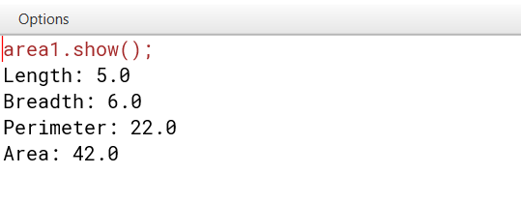

RECURSION PROGRAMS :
Question 28:
A class SeriesSum is designed to calculate the sum of the following series:-
Sum= x2/1! + x4/3!+x6/5!+….xn/(n-1)!
Some of the members of the class are given below:
Class name : SeriesSum

Data members
x : to store an integer number
n : to store number of terms
sum : double variable to store the sum of the series
Member functions :
SeriesSum(intxx,intnn) : constructor to assign x=xx, n=nn
double findfact(int m) : to return the factorial of m using recursive technique void calculate() : to calculate the sum of the series by invoking the recursive functions repeatedly
void display() : to display the sum of the series

Specify the class SeriesSum, giving details of the constructor(int,int), double findfact(int), double findpower(int,int), void calculate() and void display().
Define the main() function to create an object and call the functions accordingly to enable the task.

Algorithm:
Step 1: Start
Step 2: Initialise x to ‘xx’ and n to ‘nn’
Step 3: Read an integer and store it in ‘x’.
Step 4: Read the number of terms and store it in ‘n’.
Step 5: Let sum = 0.
Step 6: If n == 0, display sum, else, do Steps 7,8,9,10,11,12
Step 7: If 2*n == 0, return 1 to call statement
Step 8: Else, return (x*x), (2*n)-- to call statement, go to Step 7
Step 9: If (2*n-1) == 1, return 1 to call statement
Step 10: Else, return {(2*n-1) * (2*n-2 --)} to call statement, go to Step 9
Step 11: sum += (Result of Step 8) / (Result of Step 10)
Step 12: n = n-1, go to Step 6
Step 13: End

Source Code:

public class SeriesSum {

// Data members private

int x; private int n; private double sum; int exponent = 2; // Initial exponent value

// Constructor to assign x and n

public SeriesSum(int xx, int nn) {

x = xx; n = nn;

sum = 0.0;

}

// Recursive method to find the factorial of m

public double findfact(int m) {

if (m == 0 || m == 1) { return 1;

} else {

return m * findfact(m - 1);

}

}

// Recursive method to find the power of base^exp

public double findpower(int base, int exp) {

if (exp == 0) { return 1;

} else {

return base * findpower(base, exp - 1);

}

}

// Method to calculate the sum of the series

public void calculate() {

for (int i = 1; i <= n; i++) {

double term = findpower(x, exponent) / findfact(exponent - 1); sum += term;

exponent += 2; // Increment exponent by 2 for each term

}

// Method to display the sum of the series

public void display() {

System.out.println("The sum of the series is: " + sum);

}

// Main method to test the SeriesSum class

public static void main(String[] args) {

SeriesSum series = new SeriesSum(2, 5); // Example values for x and n

for(int i = 0; i < series.n; i++)

{series.calculate();}

series.display();

}

}

VDT:
Variable Name | Datatype | Function
x | int | Stores integral Value
n | int | Stores integral Value
sum | double | Stores Double Value
m | int | Stores integral Value
base | int | Stores integral Value
exp | int | Stores integral Value
exponent | int | Stores integral Value
term | double | Stores Double Value
Output:

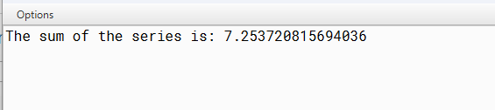
Question 29 :
A class RecFact defines a recursive function to find the factorial of a number. The details of the class are given below:
Class Name : RecFact
Data Members :
n : stores the number whose factorial is required.
r : stores an integer
Member functions :
RecFact() : default constructor
void readnum() : to enter values for n and r.
int factorial(int) : returns the factorial of the number using the recursive
technique.
voidfactseries() : to calculate and display the value of
n!
-----------------
r! * (n-r)!
Specify the class RecFact giving the details of the constructor and member functions void readnum(), int factorial(int) and void factseries(). Also define the main function to create an object and call methods accordingly to enable the task.

Algorithm:
Step 1: Start
Step 2: Let n = 0, r = 0 and series = 0
Step 3: Read the number and store it in ‘n’
Step 4: Read an integer and store it in ‘r’.
Step 5: If n == 1, return n to call statement
Step 6: Else if n == 0, return 1 to call statement
Step 7: Else n * (n-1), n--, go to Step 5
Step 8: series = (Result of Step 7) / (Result of Step 7 with n replaced by r) * (Result of Step 7
with n replaced by (n-r))
Step 9: Display series
Step 10: End

Source Code:
import java.util.Scanner;

public class RecFact {
private int n; // stores the number whose factorial is required private int r; // stores an integer

// Default constructor public RecFact() {
n = 0;
r = 0;
}

// Member function to read values for n and r public void readnum() {
Scanner scanner = new Scanner(System.in); System.out.print("Enter the value of n: "); n = scanner.nextInt(); System.out.print("Enter the value of r: "); r = scanner.nextInt();
}

// Recursive function to calculate factorial public int factorial(int num) {
if (num == 0 || num == 1) return 1;
else
return num * factorial(num - 1);
}

// Function to calculate and display the value of n! * (n-r)! public void factseries() {
int result = factorial(n) / (factorial(r) * factorial(n - r)); System.out.println("n! /r! (n-r)! = " + result);
}

public static void main(String[] args) { RecFact obj = new RecFact(); obj.readnum();
obj.factseries();
}
}

VDT:
Variable Name | Datatype | Function
n | int | Stores integral Value
r | int | Stores integral Value

Output:

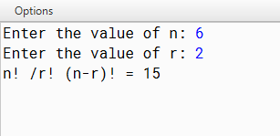

Question 30 :
An emirp number is a number which is prime backwards and forwards.
Example: 13 and 31 are
both prime numbers. Thus, 13 is an emirp number.
Design a class Emirp to check if a given number is Emirp number or not.
Some of the members
of the class are given below:
Class name: Emirp
Data members/instance variables:
n: stores the number
rev: stores the reverse of the number f: stores the divisor
Member functions:
Emirp(int nn): to assign n = nn, rev = 0 and f = 2
int isprime(int x): check if the number is prime using the recursive technique and return 1 if prime otherwise return 0
void isEmirp(): reverse the given number and check if both the original number and the reverse number are prime, by invoking the function isprime(int) and display the result with an appropriate message
Specify the class Emirp giving details of the constructor(int), int isprime (int) and void isEmirp().
Define the main function to create an object and call the methods to check for an Emirp number.
Algorithm:

STEP 1: START
STEP 2: INITIALIZE n
STEP 3: Input the value of n from user STEP 4: Check if n is prime
STEP 5: IF n is prime, then set c = 1 STEP 6: Find the reverse of n
STEP 7: Check if the reverse of n is prime
STEP 8: If the reverse of n is prime, then set c1 = 1
STEP 9: IF c & c1 are equal to 1, then print “Emirp number”, else print “Not Emirp number” STEP 10: STOP

Source Code:
import java.util.Scanner; public class Emirp
{
int n,rev,f;
Emirp(int nn)//Parameterised constructor
{
n=nn; rev=0; f=2;
}
int isprime(int x)//Checks a number whether it is a prime number or not
{
int c = 1;
for(int i = f; i < x/2; i++)
{
if(x%i == 0)
{
c = 0;
}
}
return c;
}
void isEmirp()//Checks a number whether it is a emirp number or not
{
int x=n;
while(x!=0)//finds reverse of number
{
rev=(rev*10)+x%10; x=x/10;
}
if(isprime(x)==1 && isprime(rev)==1)
{
System.out.println(n+" is an Emirp number");
}
else
{
System.out.println(n+" is not an Emirp number");
}
}
public static void main()//Main method
{
Scanner sc=new Scanner(System.in); System.out.println("Enter a number"); int x=sc.nextInt();
Emirp obj=new Emirp(x); obj.isEmirp();
}}

VDT:

Variable | Datatype | Function
n | int | Stores the integer value
x | int | Stores the integer value
nn | int | Stores the integer value
rev | int | Stores the integer value of the reverse number
f | int | Stores the integer value
i | int | Stores the integer value used in loop

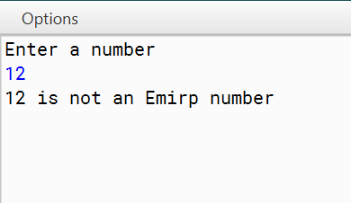
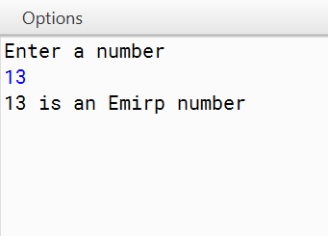
Output:

Question 31 :
Design a class VowelWord to accept a sentence and calculate the frequency of words that begin with a vowel. The words in the input string are separated by a single blank space and terminated by a full stop.
The description of the class is given below:
Class Name : VowelWord Data members
str : to store a sentence
freq : to store the frequency of words beginning with a vowel.
Member functions
VowelWord() : constructor to initialize data members to legal initial values.
Void readstr() : to accept a sentence.
void freq_vowel( ) : counts the frequency of the words beginning with a vowel.
void display() : to display the original string and the frequency of the words that begin with a vowel.
Specify the class VowelWord giving details of the constructor( ), void readstr(), void freq_vowel() and void display(). Also defing the main function to create an object and call the methods accordingly to enable the task.

Algorithm:
STEP 1: START
STEP 2: Define a class named VowelWord.
STEP 3: Declare private instance variables str (String) and freq (int).
STEP 4: Implement a constructor VowelWord() initializing str to empty string and freq to 0.
STEP 5: Create a method readstr() to accept a sentence terminated by a full stop and store it in str. STEP 6: Implement a method freq_vowel() to count the frequency of words beginning with a vowel.
STEP 7: Implement a method display() to show the original sentence and the frequency of words beginning with a vowel.
STEP 8: Define the main method.
STEP 9: Inside the main method, create an object of the VowelWord class.
STEP 10: Call the readstr(), freq_vowel(), and display() methods on the object sequentially. STEP 11: STOP

Source Code:
import java.util.Scanner;

public class VowelWord {
private String str; // to store a sentence
private int freq; // to store the frequency of words beginning with a vowel

// Constructor to initialize data members to legal initial values public VowelWord() {
str = ""; freq = 0;
}

// Method to accept a sentence public void readstr() {
Scanner scanner = new Scanner(System.in); System.out.print("Enter a sentence terminated by a full stop: "); str = scanner.nextLine();
}

// Method to count the frequency of words beginning with a vowel public void freq_vowel() {
String[] words = str.split(" "); freq = 0;
for (String word : words) {
char firstChar = word.charAt(0); if (isVowel(firstChar)) {
freq++;
}
}
}

// Method to display the original string and the frequency of words that begin with a vowel public void display() {
System.out.println("Original string: " + str); System.out.println("Frequency of words beginning with a vowel: " + freq);
}

// Helper method to check if a character is a vowel private boolean isVowel(char ch) {
ch = Character.toLowerCase(ch);
return ch == 'a' || ch == 'e' || ch == 'i' || ch == 'o' || ch == 'u';
}

public static void main(String[] args) { VowelWord obj = new VowelWord(); obj.readstr();
obj.freq_vowel(); obj.display();
}
}

VDT:

Variable Name | Datatype | Function
str | String | Stores String Value
freq | int | Stores integral Value
words[] | String[] | Stores String Value(in array)
ch | char | Stores Character Value
Output:

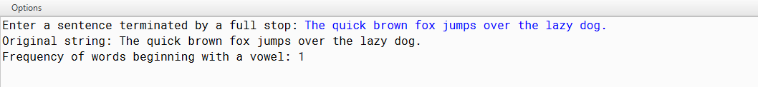

Question 32 :
Input a sentence from the user and count the number of times, the words “an” and “and” are present in the sentence. Design a class Frequency using the description given below:
Class name : Frequency Data Members
text : stores the sentence
countand : to store the frequency of the word and.
countan : to store the frequency of the word an.
len : stores the length of the string.

Member functions
Frequency() : constructor to initialize the data variables. void accept(String n) : to assign n to text where the value of the parameter should be in lowercase.
void checkandfreq(int) : to count the frequency of and using recursive technique.
void checkanfreq(int) : to count the frequency of an using recursive technique.
void display() : to display the frequency of “an” and “and” with
suitable messages.
Specify class Frequency giving details of the constructor(), void accept(String), void checkandfreq(), checkanfreq() and void display(). Also define the main function to create an object and call methods accordingly to enable the task.

Algorithm:
STEP 1: START
STEP 2: Define a class named Frequency.
STEP 3: Declare private instance variables text (String), countand (int), countan (int), and len (int).
STEP 4: Implement a constructor Frequency() initializing text, countand, countan, and len to empty string, 0, 0, and 0 respectively.
STEP 5: Create a method accept(String n) to assign n to text where the value of the parameter should be in lowercase.
STEP 6: Create a method checkandfreq(int index) to count the frequency of "and" using recursive technique. STEP 7: Create a method checkanfreq(int index) to count the frequency of "an" using recursive technique.
STEP 8: Create a method display() to display the frequency of "an" and "and" with suitable messages. STEP 9: Define the main method.
STEP 10: Inside the main method, accept a sentence from the user, create an object of the Frequency class, call accept(), checkandfreq(), checkanfreq(), and display() methods sequentially.
STEP 11: STOP

Source Code:
import java.util.Scanner;

public class Frequency {
private String text; // stores the sentence
private int countand; // to store the frequency of the word "and" private int countan; // to store the frequency of the word "an" private int len; // stores the length of the string

// Constructor to initialize the data variables public Frequency() {
text = ""; countand = 0;
countan = 0;
len = 0;
}

// Method to assign n to text where the value of the parameter should be in lowercase public void accept(String n) {
text = n.toLowerCase(); // Convert input to lowercase len = text.length(); // Calculate the length of the string
}

// Method to count the frequency of "and" using recursive technique public void checkandfreq(int index) {
if (index >= len - 3) // Base case: stop recursion if the remaining substring length is less than 3 return;

if (text.substring(index, index + 3).equals("and")) { countand++; // Increment count if "and" is found
}

// Recursively check the next substring checkandfreq(index + 1);
}

// Method to count the frequency of "an" using recursive technique public void checkanfreq(int index) {
if (index >= len - 2) // Base case: stop recursion if the remaining substring length is less than 2 return;

if (text.substring(index, index + 2).equals("an")) { countan++; // Increment count if "an" is found
}

// Recursively check the next substring checkanfreq(index + 1);
}

// Method to display the frequency of "an" and "and" with suitable messages public void display() {
System.out.println("Frequency of 'an': " + countan); System.out.println("Frequency of 'and': " + countand);
}
public static void main(String[] args) { Scanner scanner = new Scanner(System.in); System.out.print("Enter a sentence: "); String sentence = scanner.nextLine();

Frequency obj = new Frequency(); obj.accept(sentence); obj.checkandfreq(0); obj.checkanfreq(0);
obj.display();
}
}

VDT:

Variable Name | Datatype | Function
len | int | Stores integral Value
indes | int | Stores integral Value
text | String | Stores String Value
countand | int | Stores integral Value
countan | int | Stores integral Value

Output:

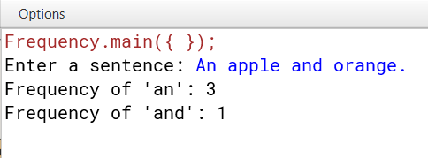

MISCELLANEOUS PROGRAMS :
Question 33 :

Read an array of integers and sort them in ascending order using Insertion Sort method.
Algorithm:
Step 1: Start
Step 2: Read array size ‘n’ and array elements into arr[] in the method accept()
Step 3 − If it is the first element, it is already sorted. return 1;
Step 4 − Pick next element
Step 5 − Compare with all elements in the sorted sub-list
Step 6 − Shift all the elements in the sorted sub-list that is greater than the
value to be sorted
Step 7 − Insert the value
Step 8 − Repeat until list is sorted
Step 9- Print the sorted array
Step 10: Stop

Source Code:
import java.util.Scanner;

public class InsertionSort
{
int arr[];
int n;

void accept() //to enter the size of the array
{
Scanner sc = new Scanner(System.in);
System.out.println("Please enter the size of the array.");
n = sc.nextInt();
arr = new int[n];
System.out.println("Please enter the elements of the array.");
for (int i = 0;i<n;i++) {
arr[i] = sc.nextInt();
}
}

void sort() //performing insertion sort
{
for (int i = 1; i < n; ++i) {
int k = arr[i];
int j = i - 1;
while (j >= 0 && arr[j] > k) {
arr[j + 1] = arr[j];
j = j - 1;
}
arr[j + 1] = k;
}
}

void display() //displaying sorted array
{
System.out.println("The sorted array is :");
for (int i = 0;i<n;i++) {
System.out.println(arr[i]);
}
}

public static void main(String[] args) //main method
{
InsertionSort ob = new InsertionSort();
ob.accept();
ob.sort();
ob.display();
}
}
Variable Description Table:
Variable Name | Data Type | Description
arr[] | int | Single-dimension integer array
n | int | Stores the array length
sc | Scanner | Scanner object to take inputs from the user
i | int | Loop control variable
k | int | Stores array element
j | int | Loop control variable
ob | InsertionSort | Object of the class to call member methods.

Output:
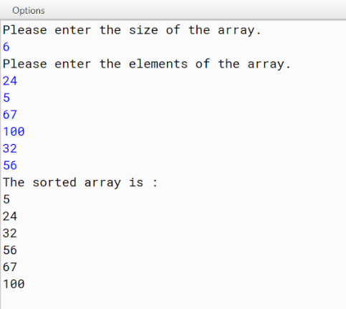

Question 34 :

Objective:
Read an array of integers and sort them in ascending order using Merge Sort method.
Algorithm:
Step 1: Start
Step 2: Read array elements into array[] and the size of the array.
Step 3: We take a variable p and store the starting index of our array in this. And we take another variable r and store the last index of array in it.
Step 4: Then we find the middle of the array using the formula (p + r)/2 and mark the middle index as q, and break the array into two subarrays, from p to q and from q + 1 to r index.
Step 5: Then we divide these 2 subarrays again, just like we divided our main array and this continues.
Step 6: Once we have divided the main array into subarrays with single elements, then we start merging the subarrays.
Step 7: Print the sorted array
Step 8: Stop

Source Code:
import java.util.Scanner;

public class MergeSort {
int array[];

void accept() //read elements into the array and the size of the array
{
Scanner sc = new Scanner(System.in);
System.out.println("Please enter the number of elements.");
array = new int[sc.nextInt()];
System.out.println("Please enter the elements.");
for (int i = 0; i < array.length; i++) {
array[i] = sc.nextInt();
}
}

void merge(int[] array, int low, int mid, int high) //sorting array
{

int leftArray[] = new int[mid - low + 1];
int rightArray[] = new int[high - mid];

for (int i = 0; i < leftArray.length; i++)
leftArray[i] = array[low + i];
for (int i = 0; i < rightArray.length; i++)
rightArray[i] = array[mid + i + 1];

int leftIndex = 0;
int rightIndex = 0;

for (int i = low; i < high + 1; i++) {
if (leftIndex < leftArray.length && rightIndex < rightArray.length) {
if (leftArray[leftIndex] < rightArray[rightIndex]) {
array[i] = leftArray[leftIndex];
leftIndex++;
} else {
array[i] = rightArray[rightIndex];
rightIndex++;
}
} else if (leftIndex < leftArray.length) {
array[i] = leftArray[leftIndex];
leftIndex++;
} else if (rightIndex < rightArray.length) {
array[i] = rightArray[rightIndex];
rightIndex++;
}
}
}

void display() //display sorted array
{
System.out.println("The sorted elements are:");
for (int i = 0; i < array.length; i++) {
System.out.println(array[i]);
}
}

void mergeSort(int[] array, int low, int high)
{
if (high <= low) return;
int mid = (low + high) / 2;
mergeSort(array, low, mid);
mergeSort(array, mid + 1, high);
merge(array, low, mid, high);
}

public static void main(String args[]) // main method to call member methods
{
MergeSort ob = new MergeSort();
ob.accept();
ob.mergeSort(ob.array, 0, ob.array.length - 1);
ob.display();
}
}

Variable Description Table:
Variable Name | Data Type | Description
array[] | int | Single-dimensional integer array
Sc | Scanner | Scanner object to take inputs
I | int | Loop control variable
Low | int | Stores an integer
Mid | int | Stores an integer
High | int | Stores an integer
leftArray[] | int | Single-dimensional integer array
rightArray[] | int | Single-dimensional integer array
leftIndex | int | Stores an integer
rightIndex | int | Stores an integer
Ob | MergeSort | Object of the class to call member methods

Output:
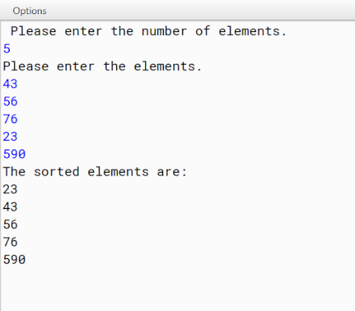

Question 35 :

Read an array of integers and sort them in ascending order using Quick Sort method.
Algorithm:
Step 1: Start
Step 2: Read array elements into array[] and the size of the array.
Step 3 − Choose the highest index value has pivot
Step 4 − Take two variables to point left and right of the list excluding pivot
Step 5 − left points to the low index
Step 6 − right points to the high
Step 7 − while value at left is less than pivot move right
Step 8 − while value at right is greater than pivot move left
Step 9 − if both step 5 and step 6 does not match swap left and right
Step 10 − if left ≥ right, the point where they met is new pivot
Step 11- Print the sorted array
Step 12: Stop

Source Code:
import java.util.Scanner;

public class QuickSort {
int arr[];

void accept() //reads array size
{
Scanner sc = new Scanner(System.in);
System.out.println("Please enter size of the array.");
int n = sc.nextInt();
arr = new int[n];
System.out.println("Please enter the elements of the array.");
for (int i = 0; i < n; i++) {
arr[i] = sc.nextInt();
}
}

int partition(int start, final int end) //partitions array elements into subarrays
{
for (int i = start; i < end; i++) {
if (arr[i] < arr[end]) {
swap(start, i);
start++;
}
}
swap(start, end);
return start;
}

void swap(int left, int right) //swaps array elements
{
int temp = arr[left];
arr[left] = arr[right];
arr[right] = temp;
}

void sort(int left, int right) //sorting using quick sort logic
{
if (left < right) {
int pivot = partition(left, right);
sort(left, pivot - 1);
sort(pivot + 1, right);
}
}

void display() //display sorted array
{
System.out.println("The sorted array is:");
for (int value : arr) {
System.out.println(value);
}
}

public static void main(String[] args) //main method to call member methods
{
QuickSort ob = new QuickSort();
ob.accept();
ob.sort(), ob.arr.length - 1);
ob.display();
}
}
Variable Description Table:
Variable Name | Data Type | Description
arr[] | int | Single-dimension integer array
sc | Scanner | Scanner object to take input
n | int | Stores the array size
i | int | Loop control variable
start | int | Stores starting position of the array
end | int | Stores end position in the array
left | int | Stores an integer value
right | int | Stores an integer value
temp | int | Stores an integer value
ob | QuickSort | Object of the class to call member methods.

Output:
